

**FLIGHT PRICE PREDICTION**

Submitted by:

Ankita Chaudhari

**ACKNOWLEDGMENT**

1. O. Etzioni, R. Tuchinda, C. A. Knoblock, and A. Yates. To buy or not to buy: mining airfare data to

minimize ticket purchase price.

2. Manolis Papadakis. Predicting Airfare Prices.

3. Groves and Gini, 2011. A Regression Model For Predicting Optimal Purchase Timing For Airline

Tickets.

4. Modeling of United States Airline Fares – Using the Official Airline Guide (OAG) and Airline Origin

and Destination Survey (DB1B), Krishna Rama-Murthy, 2006.

5. B. S. Everitt: The Cambridge Dictionary of Statistics



, Cambridge University Press, Cambridge (3rd

edition, 2006). ISBN 0-521-69027-7.

6. Bishop: Pattern Recognition and Machine Learning



, Springer, ISBN 0-387-31073-8.

7. E. Bachis and C. A. Piga. Low-cost airlines and online price dispersion. International Journal of

Industrial Organization, In Press, Corrected Proof, 2011.

8. P. P. Belobaba. Airline yield management. an overview of seat inventory control. Transportation

Science, 21(2):63, 1987.

9. Y. Levin, J. McGill, and M. Nediak. Dynamic pricing in the presence of strategic consumers and

oligopolistic competition. Management Science, 55(1):32–46, 2009.

1. O. Etzioni, R. Tuchinda, C. A. Knoblock, and A. Yates. To buy or not to buy: mining airfare data to

minimize ticket purchase price.

2. Manolis Papadakis. Predicting Airfare Prices.

3. Groves and Gini, 2011. A Regression Model For Predicting Optimal Purchase Timing For Airline

Tickets.

4. Modeling of United States Airline Fares – Using the Official Airline Guide (OAG) and Airline Origin

and Destination Survey (DB1B), Krishna Rama-Murthy, 2006.

5. B. S. Everitt: The Cambridge Dictionary of Statistics



, Cambridge University Press, Cambridge (3rd

edition, 2006). ISBN 0-521-69027-7.

6. Bishop: Pattern Recognition and Machine Learning



, Springer, ISBN 0-387-31073-8.

7. E. Bachis and C. A. Piga. Low-cost airlines and online price dispersion. International Journal of

Industrial Organization, In Press, Corrected Proof, 2011.

8. P. P. Belobaba. Airline yield management. an overview of seat inventory control. Transportation

Science, 21(2):63, 1987.

9. Y. Levin, J. McGill, and M. Nediak. Dynamic pricing in the presence of strategic consumers and

oligopolistic competition. Management Science, 55(1):32–46, 2009.

. 1. O. Etzioni, R. Tuchinda, C. A. Knoblock, and A. Yates. To buy or not to buy: mining airfare data to

minimize ticket purchase price.

2. Manolis Papadakis. Predicting Airfare Prices.

3. Groves and Gini, 2011. A Regression Model For Predicting Optimal Purchase Timing For Airline

Tickets.

4. Modeling of United States Airline Fares – Using the Official Airline Guide (OAG) and Airline Origin

and Destination Survey (DB1B), Krishna Rama-Murthy, 2006.

5. B. S. Everitt: The Cambridge Dictionary of Statistics



, Cambridge University Press, Cambridge (3rd

edition, 2006). ISBN 0-521-69027-7.

6. Bishop: Pattern Recognition and Machine Learning



, Springer, ISBN 0-387-31073-8.

7. E. Bachis and C. A. Piga. Low-cost airlines and online price dispersion. International Journal of

Industrial Organization, In Press, Corrected Proof, 2011.

8. P. P. Belobaba. Airline yield management. an overview of seat inventory control. Transportation

Science, 21(2):63, 1987.

9. Y. Levin, J. McGill, and M. Nediak. Dynamic pricing in the presence of strategic consumers and

oligopolistic competition. Management Science, 55(1):32–46, 2009.

1. O. Etzioni, R. Tuchinda, C. A. Knoblock, and A. Yates. To buy or not to buy: mining airfare data to

minimize ticket purchase price.

2. Manolis Papadakis. Predicting Airfare Prices.

3. Groves and Gini, 2011. A Regression Model For Predicting Optimal Purchase Timing For Airline

Tickets.

4. Modeling of United States Airline Fares – Using the Official Airline Guide (OAG) and Airline Origin

and Destination Survey (DB1B), Krishna Rama-Murthy, 2006.

5. B. S. Everitt: The Cambridge Dictionary of Statistics



, Cambridge University Press, Cambridge (3rd

edition, 2006). ISBN 0-521-69027-7.

6. Bishop: Pattern Recognition and Machine Learning



, Springer, ISBN 0-387-31073-8.

7. E. Bachis and C. A. Piga. Low-cost airlines and online price dispersion. International Journal of

Industrial Organization, In Press, Corrected Proof, 2011.

8. P. P. Belobaba. Airline yield management. an overview of seat inventory control. Transportation

Science, 21(2):63, 1987.

9. Y. Levin, J. McGill, and M. Nediak. Dynamic pricing in the presence of strategic consumers and

oligopolistic competition. Management Science, 55(1):32–46, 2009.

1. O. Etzioni, R. Tuchinda, C. A. Knoblock, and A. Yates. To buy or not to buy: mining airfare data to

minimize ticket purchase price.

2. Manolis Papadakis. Predicting Airfare Prices.

3. Groves and Gini, 2011. A Regression Model For Predicting Optimal Purchase Timing For Airline

Tickets.

4. Modeling of United States Airline Fares – Using the Official Airline Guide (OAG) and Airline Origin

and Destination Survey (DB1B), Krishna Rama-Murthy, 2006.

5. B. S. Everitt: The Cambridge Dictionary of Statistics



, Cambridge University Press, Cambridge (3rd

edition, 2006). ISBN 0-521-69027-7.

6. Bishop: Pattern Recognition and Machine Learning



, Springer, ISBN 0-387-31073-8.

7. E. Bachis and C. A. Piga. Low-cost airlines and online price dispersion. International Journal of

Industrial Organization, In Press, Corrected Proof, 2011.

8. P. P. Belobaba. Airline yield management. an overview of seat inventory control. Transportation

Science, 21(2):63, 1987.

9. Y. Levin, J. McGill, and M. Nediak. Dynamic pricing in the presence of strategic consumers and

oligopolistic competition. Management Science, 55(1):32–46, 2009.

1. O. Etzioni, R. Tuchinda, C. A. Knoblock, and A. Yates. To buy or not to buy: mining airfare data to minimize ticket purchase price.

2. Manolis Papadakis. Predicting Airfare Prices.

3. Groves and Gini, 2011. A Regression Model For Predicting Optimal Purchase Timing For Airline Tickets.

4. Modeling of United States Airline Fares – Using the Official Airline Guide (OAG) and Airline Origin and Destination Survey (DB1B), Krishna Rama-Murthy, 2006.

5. B. S. Everitt: The Cambridge Dictionary of Statistics, Cambridge University Press, Cambridge (3rd edition, 2006). ISBN 0-521-69027-7.

6. Bishop: Pattern Recognition and Machine Learning, Springer, ISBN 0-387-31073-8.

7. E. Bachis and C. A. Piga. Low-cost airlines and online price dispersion. International Journal of Industrial Organization, In Press, Corrected Proof, 2011.

8. P. P. Belobaba. Airline yield management. an overview of seat inventory control. Transportation Science, 21(2):63, 1987.

9. Y. Levin, J. McGill, and M. Nediak. Dynamic pricing in the presence of strategic consumers and oligopolistic competition. Management Science, 55(1):32–46, 2009.

**INTRODUCTION**

**Business Problem Framing**

Airline companies use complex algorithms to calculate flight prices given various conditions present at that particular time. These methods take financial, marketing, and various social factors into account to predict flight prices. Nowadays, the number of people using flights has increased significantly. It is difficult for airlines to maintain prices since prices change dynamically due to different conditions. That’s why we will try to use machine learning to solve this problem. This can help flights by predicting what prices they can maintain. It can also help customers to predict future flight prices and plan their journey accordingly.

**Conceptual Background of the Domain Problem**

1. Anyone who has booked a flight ticket knows how unexpectedly the prices vary. Airlines use using sophisticated quasi-academic tactics known as "revenue management" or "yield management". The cheapest available ticket for a given date gets more or less expensive over time. This usually happens as an attempt to maximize revenue based on –

2. Time of purchase patterns (making sure last-minute purchases are expensive)

3. Keeping the flight as full as they want it (raising prices on a flight which is filling up in order to reduce sales and hold back inventory for those expensive last-minute expensive purchases) So, if we could inform the travellers with the optimal time to buy their flight tickets based on the historic data and also show them various trends in the airline industry we could help them save money on their travels. This would be a practical implementation of a data analysis, statistics and machine learning techniques to solve a daily problem faced by travellers. The objectives of the project can broadly be laid down by the following questions –

Flight Trends Do airfares change frequently? Do they move in small increments or in large jumps? Do they tend to go up or down over time?

Best Time To Buy What is the best time to buy so that the consumer can save the most by taking the least risk? So should a passenger wait to buy his ticket, or should he buy as early as possible? 3. Verifying Myths Does price increase as we get near to departure date? Is Indigo cheaper than Jet Airways? Are morning flights expensive?.

**Review of Literature**

It is very difficult for the customer to purchase a flight ticket at the minimum price. For this several techniques are used to obtain the day at which the price of air ticket will be minimum. Most of these techniques are using sophisticated artificial intelligence(AI) research is known as Machine Learning.

**Motivation for the Problem Undertaken**

The most important motivation for this project is to help airline industry software manufacturers utilizing machine learning algorithms inside their software products enabling them for prediction capabilities, so their customers which are airline companies would be able to have near future forecasts and use this knowledge to prevent delays by different causes in their schedules. Delays can impose variety of costs to airline companies which in fact by reducing small amounts of delays, huge amounts of company revenue would be affected.

**Analytical Problem Framing**

**1.What is Statistical Modeling and How is it Used?**

Statistical modelingis the process of applying statistical analysis to a dataset. A statistical model is a mathematical representation (or mathematical model) of observed data.

When [data analysts](https://www.northeastern.edu/graduate/blog/what-does-a-data-analyst-do/) apply various statistical models to the data they are investigating, they are able to understand and interpret the information more strategically. Rather than sifting through the raw data, this practice allows them to identify relationships between variables, [make predictions](https://www.northeastern.edu/graduate/blog/predictive-analytics/) about future sets of data, and visualize that data so that non-analysts and stakeholders can consume and leverage it.

“When you analyze data, you are looking for patterns,” says Mello. “You are using a sample to make an inference about the whole.”

## Important Statistical Techniques in Data Analysis

Before any statistical model can be created, an analyst needs to collect or fetch the data housed on a database, clouds, social media, or within a plain excel file. To do this, analysts must also have a solid grasp of data structure and management, including how and where data is stored, fetched, and maintained. Those working in this field should thus share a passion for facts and data, and understand the basics of data manipulation, as well.

Once it comes time to analyze the data, there are an array of statistical models analysts may choose to utilize. According to Mello, most common techniques will fall into the following two groups:

* Supervised learning, including regression and classification models.
* Unsupervised learning, including clustering algorithms and association rules.

### Regression Models

Data analysts use **regression models** to examine relationships between variables. Regression models are often used by organizations to determine which independent variables hold the most influence over dependent variables—information that can be leveraged to make essential [business decisions](https://www.northeastern.edu/graduate/blog/data-driven-decision-making/).

“The most traditional regression models that have been used for a long time are logistic regression, linear regression, and polynomial regression,” Mello says. “These are the most common.”

Other examples of regression models can include stepwise regression, ridge regression, lasso regression, and elastic net regression.

### Classification Models

**Classification** is a process in which an algorithm is used to analyze an existing data set of known points. The understanding achieved through that analysis is then leveraged as a means of appropriately classifying the data. Classification is a form of machine learning that can be particularly helpful in analyzing very large, complex sets of data to help make more accurate predictions.

“Classification models are a form of supervised machine learning which is often used when the analyst needs to understand how they got to a certain point,” Mello says. “They give you more than just an output; [they give you] more information that you can use to explain the results of the prediction to your boss or stakeholder.”

Some of the most common classification models include decision trees, random forests, nearest neighbor, and  Naive Bayes.

There are also the neural networking models that are more used in AI. “These are very powerful models, and they can make accurate predictions very well,” Mello says, “but you typically cannot explain what is happening behind the scenes.”

**Types of the Model:**

Here it is the regression modeling technique use because in this dataset **price** is target variable and in this columns all continuous values are present so use regression models.

**Problem Definition:**

Anyone who has booked a flight ticket knows how unexpectedly the prices vary. The cheapest available ticket on a given flight gets more and less expensive over time. This usually happens as an attempt to maximize revenue based on - 1. Time of purchase patterns (making sure last-minute purchases are expensive) 2. Keeping the flight as full as they want it (raising prices on a flight which is filling up in order to reduce sales and hold back inventory for those expensive last-minute expensive purchases) So, you have to work on a project where you collect data of flight fares with other features and work to make a model to predict fares of flights.

**Data Analysis**

After cleaning the data, you have to do some analysis on the data. Do airfares change frequently? Do they move in small increments or in large jumps? Do they tend to go up or down over time? What is the best time to buy so that the consumer can save the most by taking the least risk? Does price increase as we get near to departure date? Is Indigo cheaper than Jet Airways? Are morning flights expensive?.

**DataSet:**

**Regression Analysis**:

Regression analysis is used to estimate the relationship between a set of variables. When conducting any [type of regression analysis](https://careerfoundry.com/en/blog/data-analytics/what-is-logistic-regression/), you’re looking to see if there’s a correlation between a dependent variable (that’s the variable or outcome you want to measure or predict) and any number of independent variables (factors which may have an impact on the dependent variable). The aim of regression analysis is to estimate how one or more variables might impact the dependent variable, in order to identify trends and patterns. This is especially useful for making predictions and forecasting future trends.

Regression analysis is a type of predictive modeling technique which is used to find the relationship between a dependent variable (usually known as the “Y” variable) and either one independent variable (the “X” variable) or a series of independent variables. When two or more independent variables are used to predict or explain the outcome of the dependent variable, this is known as multiple regression

**Types of Regressor models**:

* Linear Regressor..
* Ridge Regressor.
* Lasso Regressor.
* Decision Tree Regressor.
* RandomForest Regressor
* GradientBoost Regressor
* KNN Regressor.
* AdaBoost Regressor.

**Introduction**

Airline companies use complex algorithms to calculate flight prices given various conditions present at that particular time. These methods take financial, marketing, and various social factors into account to predict flight prices. Nowadays, the number of people using flights has increased significantly. It is difficult for airlines to maintain prices since prices change dynamically due to different conditions. That’s why we will try to use machine learning to solve this problem. This can help airlines by predicting what prices they can maintain. It can also help customers to predict future flight prices and plan their journey accordingly.

**Objective**:

The objective of this article is to predict flight prices given the various parameters.This will be a regression problem since the target or dependent variable is the price (continuous numeric value).

**Data Loading and Visualisations:**

The first and foremost step involves importing necessary libraries and packages and loading the dataset as a pandas dataframe. Data visualization is the graphical representation of information and data. By using [visual elements like charts, graphs, and maps](https://www.tableau.com/learn/articles/data-visualization/glossary), data visualization tools provide an accessible way to see and understand trends, outliers, and patterns in data.

In the world of Big Data, data visualization tools and technologies are essential to analyze massive amounts of information and make data-driven decisions.

Our eyes are [drawn to colors and patterns](https://www.tableau.com/learn/whitepapers/tableau-visual-guidebook). We can quickly identify red from blue, square from circle. Our culture is visual, including everything from art and advertisements to TV and movies. Data visualization is another form of visual art that grabs our interest and keeps our eyes on the message. When we see a chart, we [quickly see trends and outliers](https://www.tableau.com/reports/business-intelligence-trends). If we can see something, we internalize it quickly. It’s storytelling with a purpose. If you’ve ever stared at a massive spreadsheet of data and couldn’t see a trend, you know how much more effective a visualization can be.

**Importing libraries**

We will start by importing the libraries we will require for performing EDA. These include NumPy, Pandas, Matplotlib, and Seaborn.

### Reading data:

We will now read the data from a CSV file into a Pandas DataFrame in this there are two dataset first is train dataset and second is test dataset.

Install This project requires anaconda python, because below libraries already available.

• Numpy

• Matplotlib

• Seaborn

• Skit-learn

• Pandas

Also need to have software.

Install, run and execute a Jupyter notebook.

**EDA**:

There are no shortcuts in a machine learning project lifecycle. We can’t simply skip to the model building stage after gathering the data. We need to plan our approach in a structured manner and the exploratory data analytics (EDA) stage plays a huge part in that. I can say this with the benefit of hindsight having personally gone through this situation plenty of times. In my early days in this field, I couldn’t wait to dive into machine learning algorithms but that often left my end result hanging in the balance. I discovered, through personal experience and the advice of my mentors, the importance of spending time exploring and understanding my data.

## The Importance of Exploratory Data Analysis (EDA): There are no shortcuts in a machine learning project lifecycle. We can’t simply skip to the model building stage after gathering the data. We need to plan our approach in a structured manner and the exploratory data analytics (EDA) stage plays a huge part in that. I can say this with the benefit of hindsight having personally gone through this situation plenty of times. In my early days in this field, I couldn’t wait to dive into machine learning algorithms but that often left my end result hanging in the balance. I discovered, through personal experience and the advice of my mentors, the importance of spending time exploring and understanding my data.

**Loading dataset :**

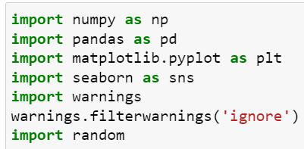

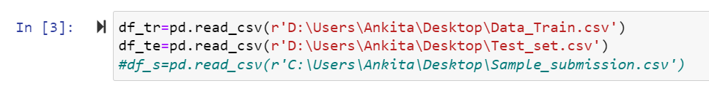

Here importing all necessary library and also load Train and Test dataset.

**Data Sources and their formats**

Then need to read and load house dataset. And Then this below code isusefor display all the columns in dataset. Let us have a look at how our dataset

The structure and details of the data are given below in this there are dataset in which no of row and columns are present:

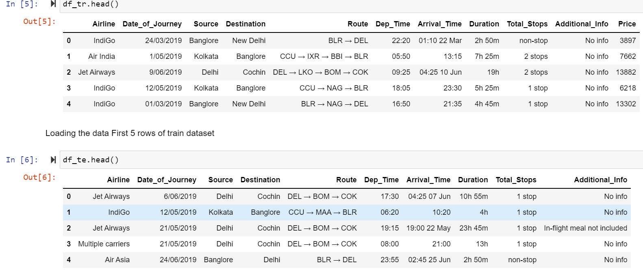

Here Price is our Target Variable in Train dataset and in Test dataset there was no target variable and in Train dataset Price are target variable and there was continues numeric values are present so this is **Regression Problem** so Need use Regression Algorithm.

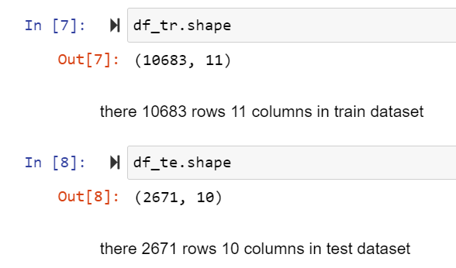

Check the how much Columns and rows present in dataset using df.shape() is use to check the rows and columns count in this above dataset there are 10683 rows and 11 columns are present in train dataset and 2671 rows and 10 columns are present in test dataset.

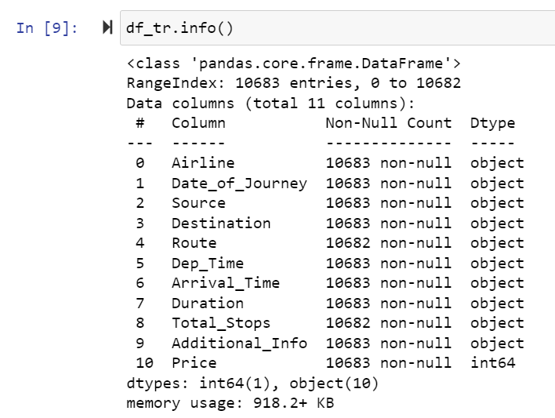 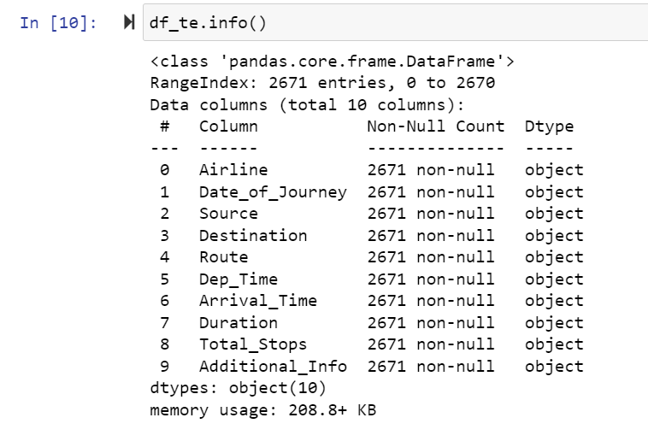

In above using df.info() is used to get the information all the columns in dataset and its data types. In above dataset there are 11 columns in traindataset and 10 columns are in test dataset

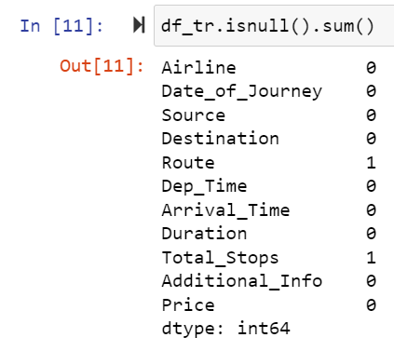  **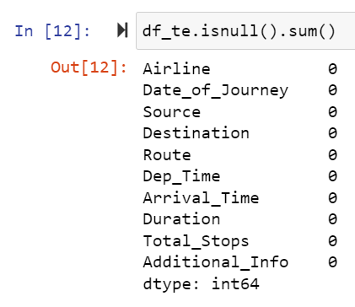**

Check the how much missing values present in dataset using df.isnull() is use to check the missing values in dataset in this dataset there are 2 columns missing values are present and no missing are present in test dataset.

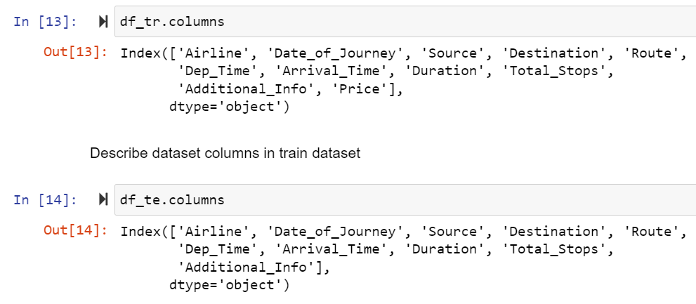

In above df.colums is use to get all the column names in train dataset and test dataset.

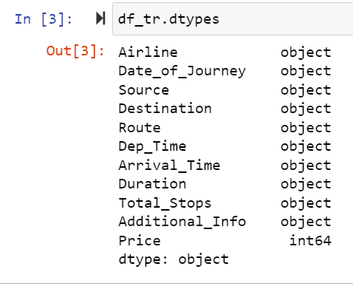 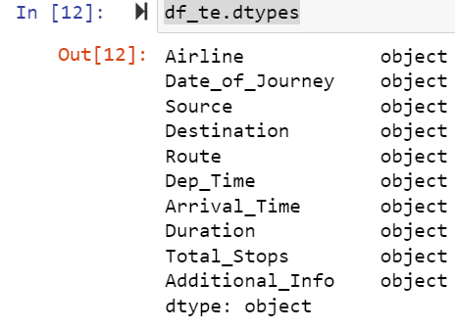

In above code df.dtypes is used to check the data types of all the column In above train and test dataset.

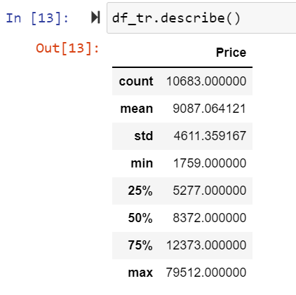

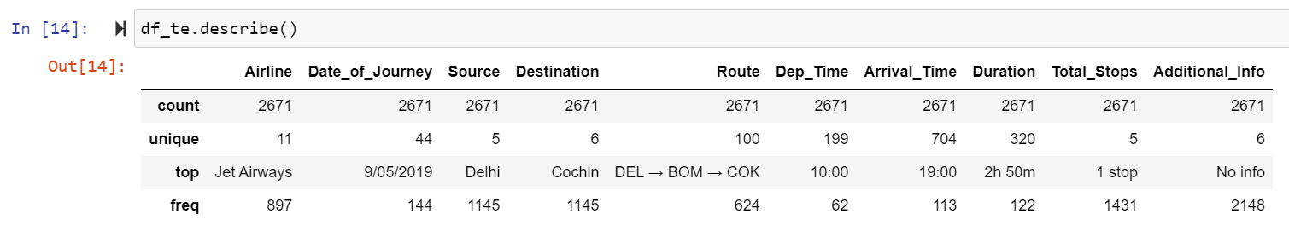

Above describe the information of train and test dataset using df.describe().

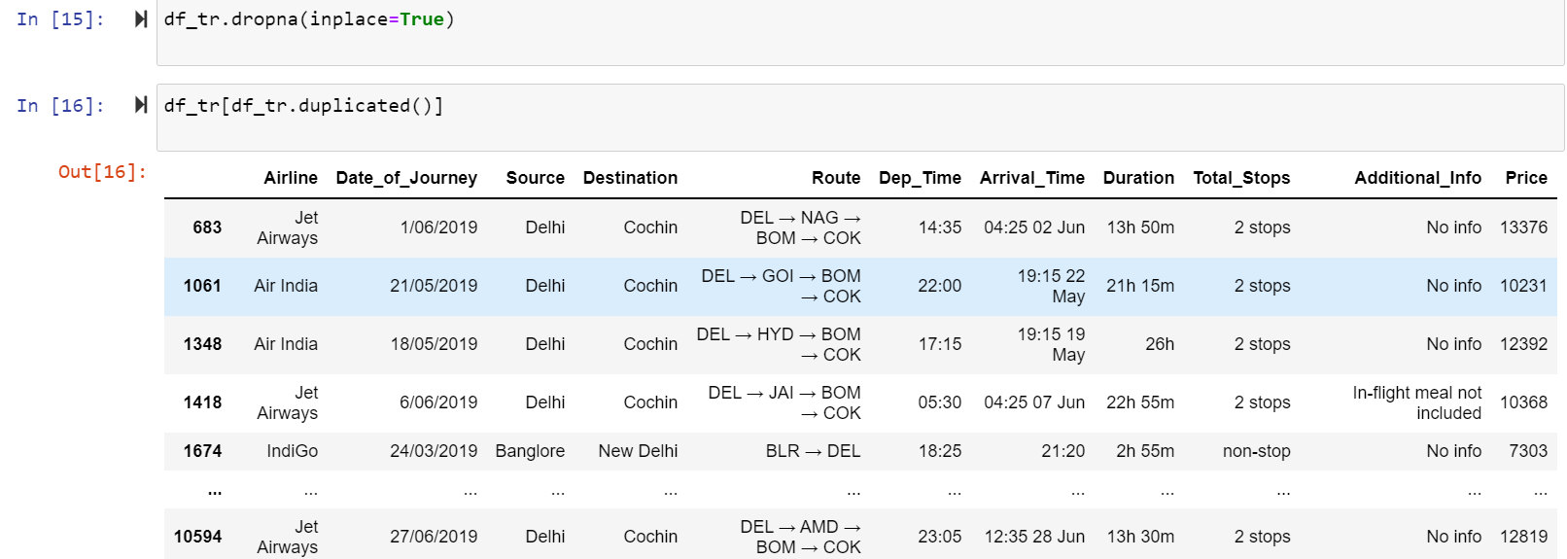

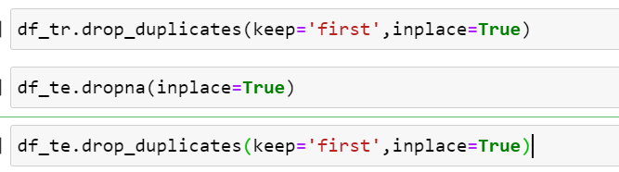

Above check the duplicates values of train and test dataset there was some duplicates values are present in train and test dataset and drop that duplicate values.

**Data Preprocessing Done**

**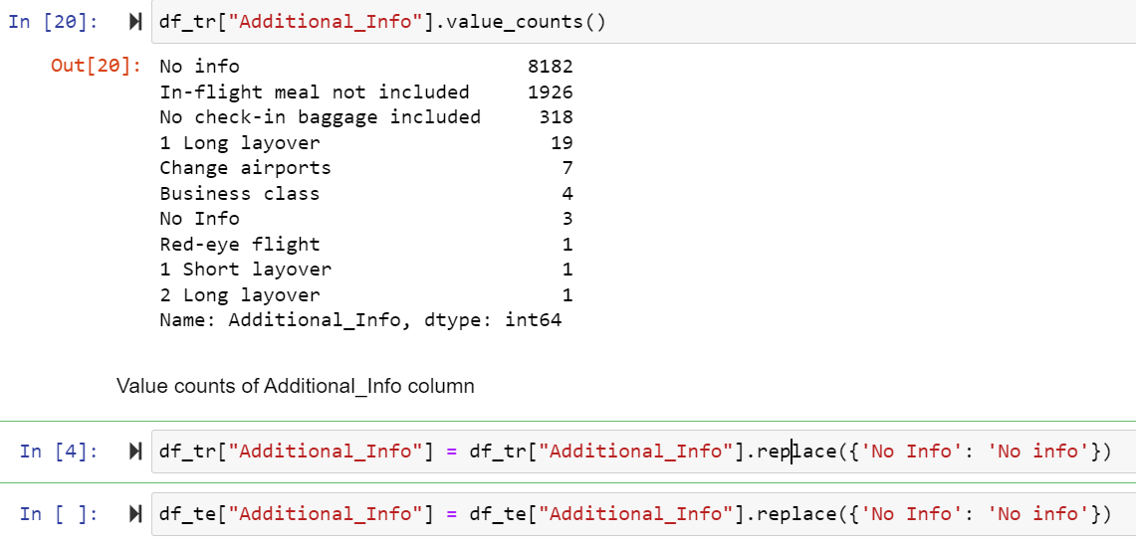**

Here in above Train dataset Additional\_Info column replace some values name in this column.

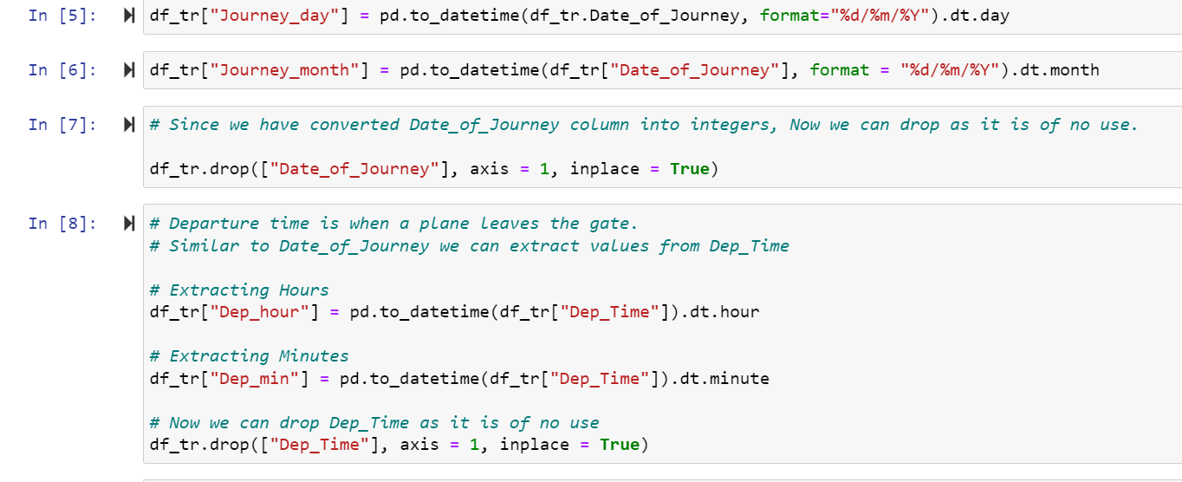

Here in above Train dataset Journey\_day and Journey\_month columns in this convert this column into hour and minute.

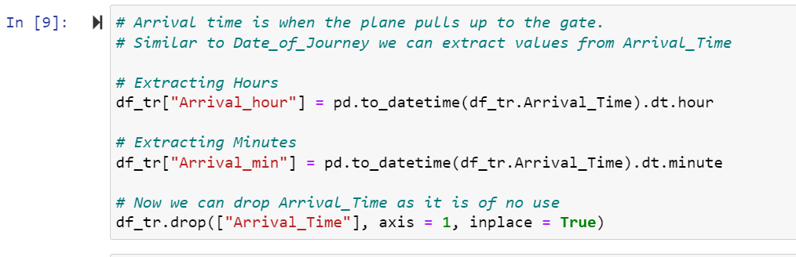

Here in above Train dataset Arrival\_Time column in this convert this column into hour and minute.

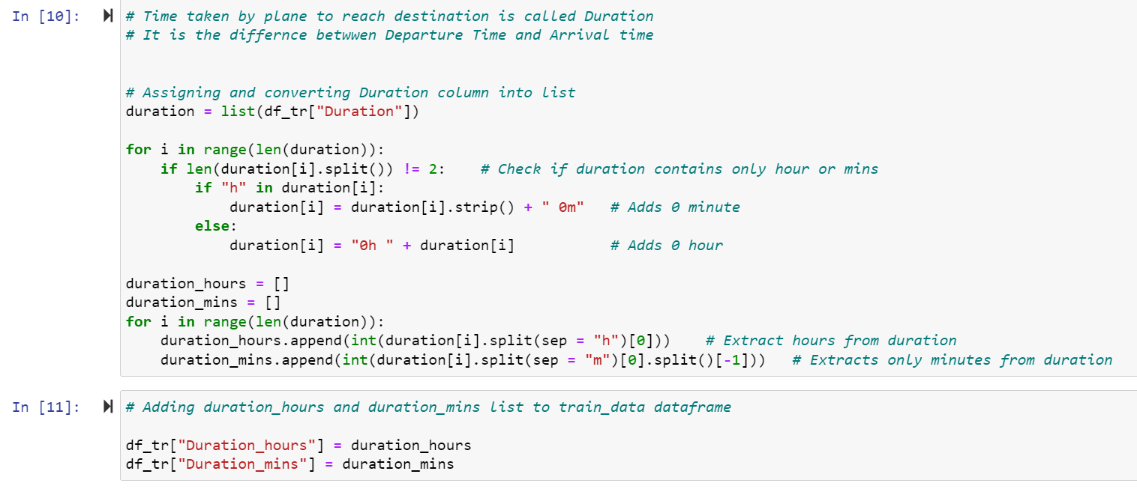

Here in above Train dataset **Duration** column in this convert this column into hour and minute.

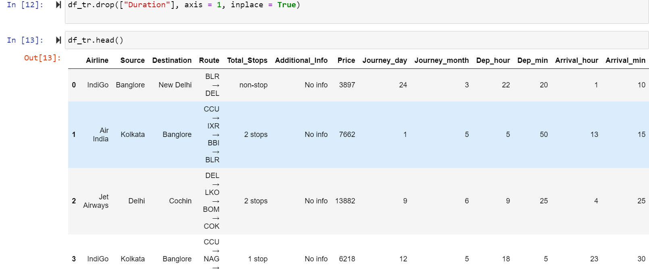

After convert column in train dataset and display the table.

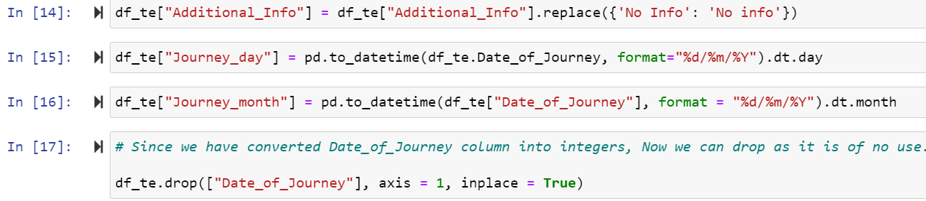

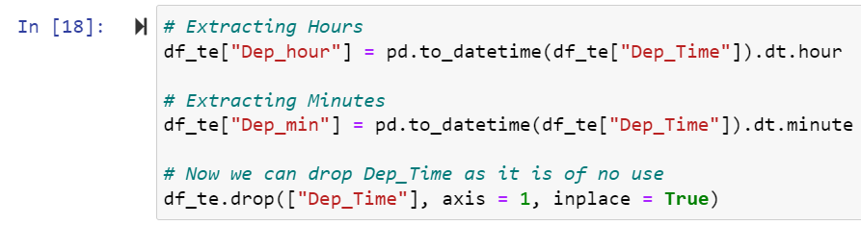

Here in above Test dataset Additional\_Info column replace some values name in this column.

Here in above Test dataset Journey\_day and Journey\_month columns in this convert this column into hour and minute.

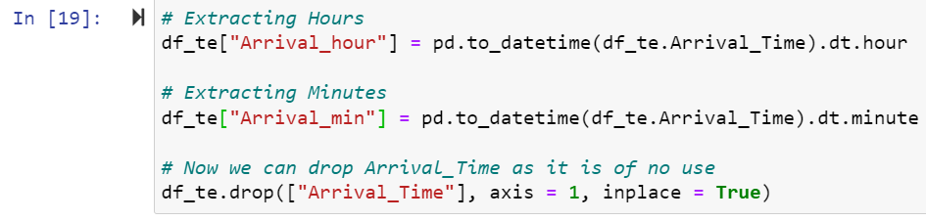

Here in above Test dataset Arrival\_Time column in this convert this column into hour and minute.

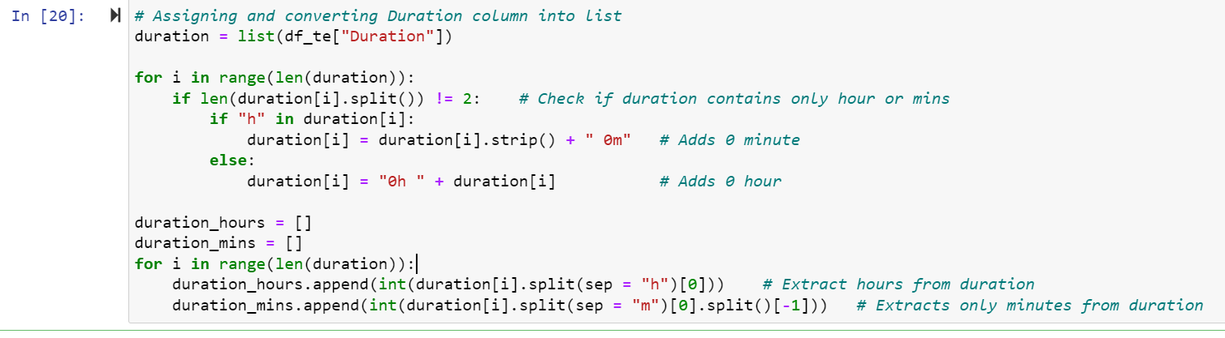

Here in above Train dataset **Duration** c olumn in this convert this column into hour and minute.

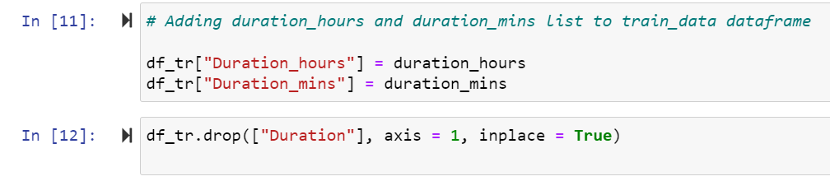

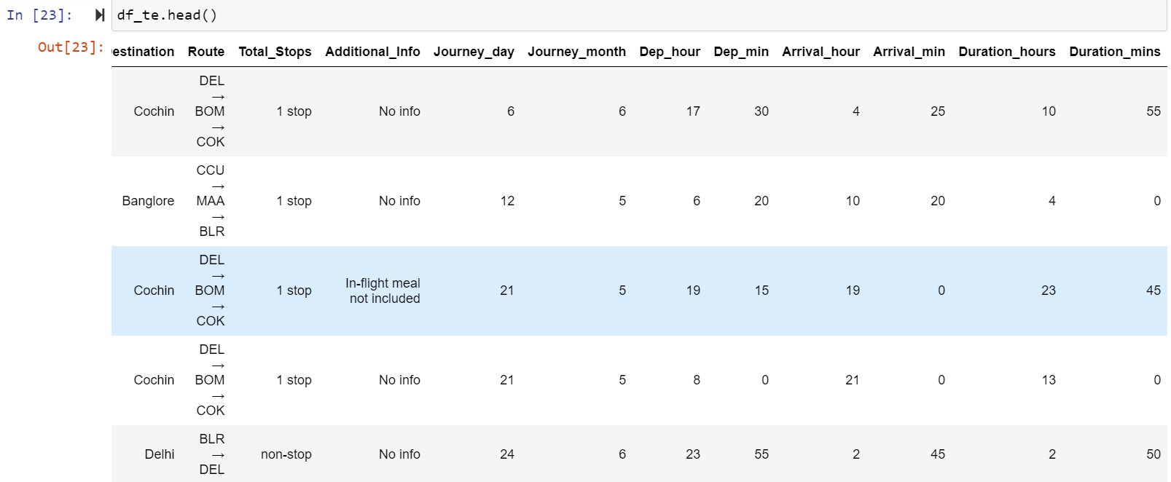

After convert column in test dataset and display the table.

**Graphical representation**

### We will start with Univariate Analysis. We will be using a bar graph for this purpose.

1. Univarient Analysis.
2. Bi Varient Analysis
3. Multivarient Analysis

**Univarient Analysis of Train dataset**:

Univariate analysis **explores each variable in a data set**, separately. It looks at the range of values, as well as the central tendency of the values. It describes the pattern of response to the variable. It describes each variable on its own.

**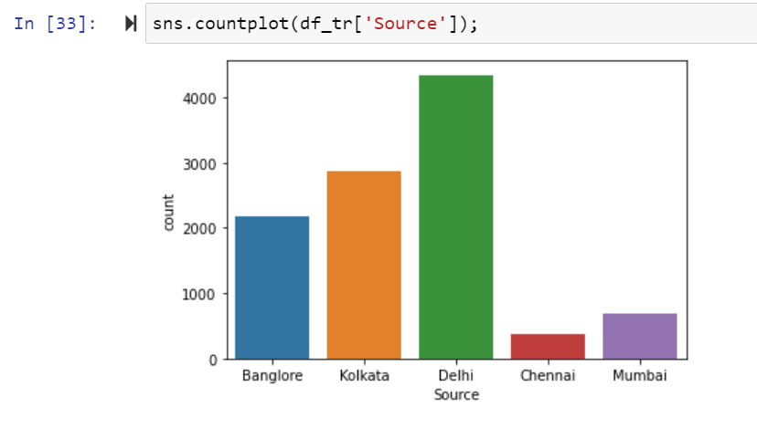 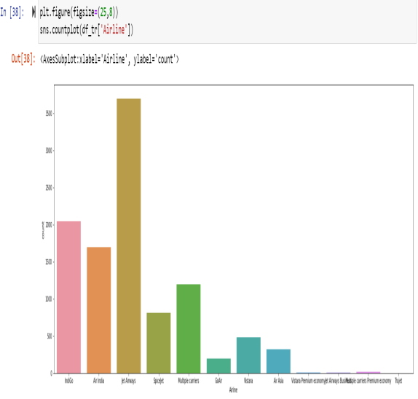**

Univarient analysis of ‘Source’ and ‘Airline’ column in train dataset.

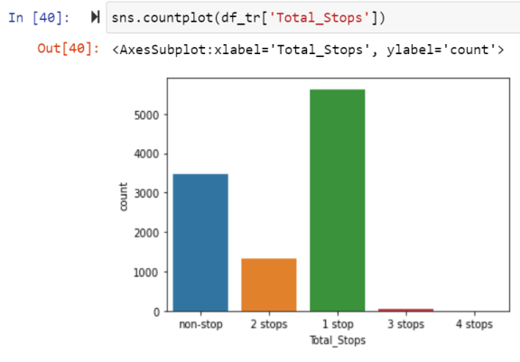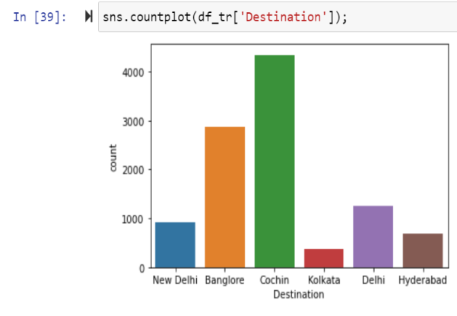

Univarient analysis of ‘Total\_Stops’ and ‘Destination’ column in train dataset.

estination'the variable. It destaset and display the table.lumns in this convert this column into hour and minute.**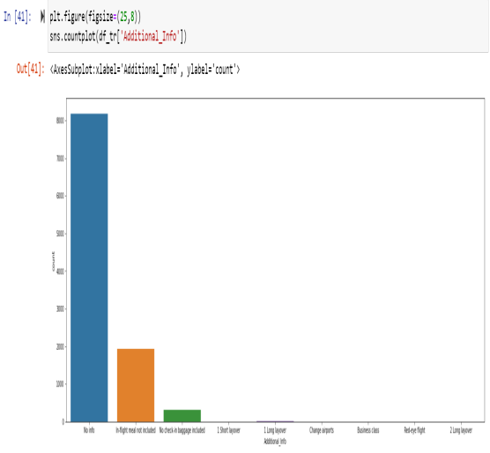** **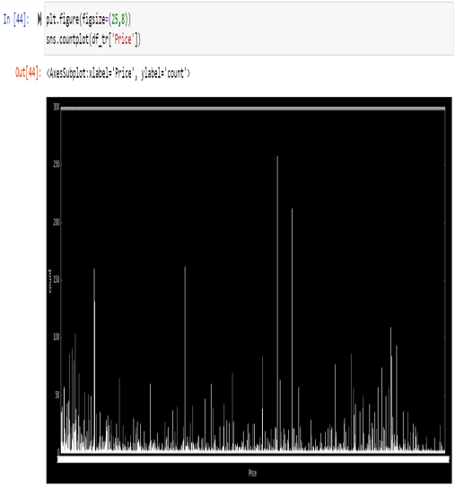**

Univarient analysis of ‘Additional\_Info’ and ‘Price’ column in train dataset.

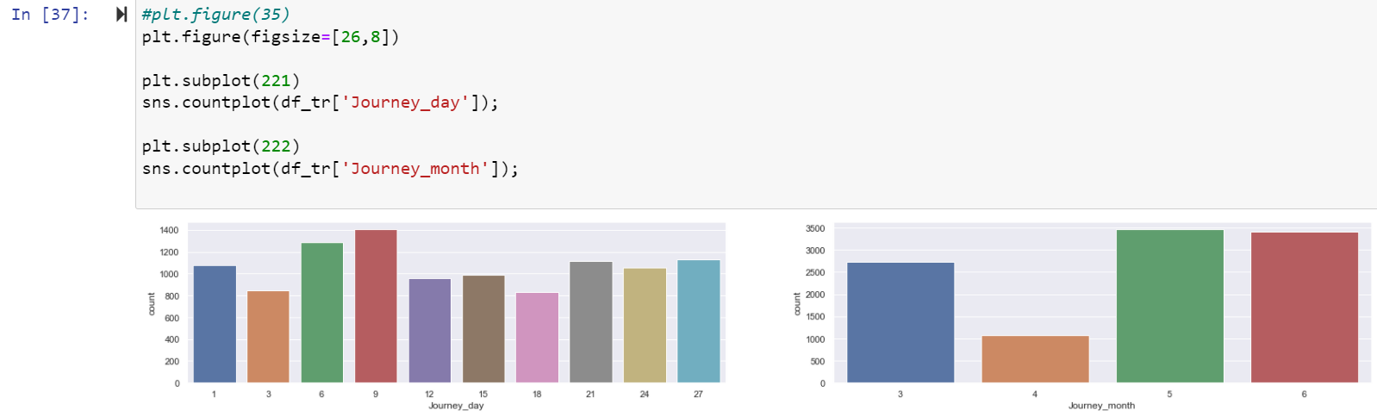

Univarient analysis of ‘Journey\_day’ and ‘Journey\_month’ column in train dataset.

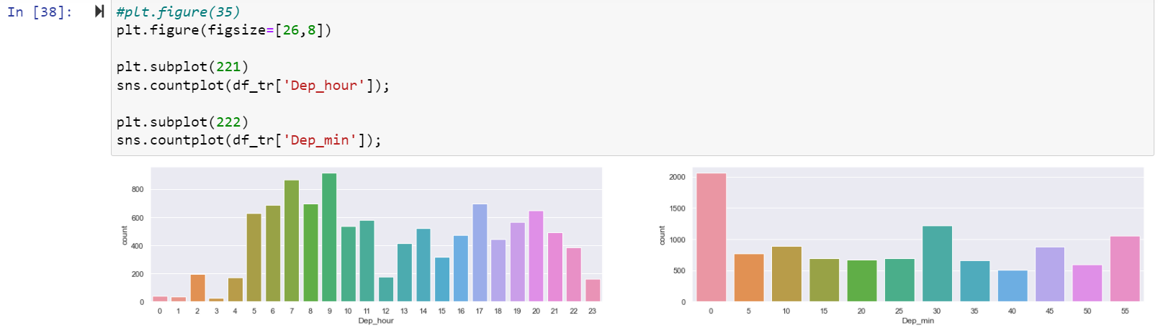

Univarient analysis of ‘Dep\_hour’ and ‘Dep-min’ column in train dataset.

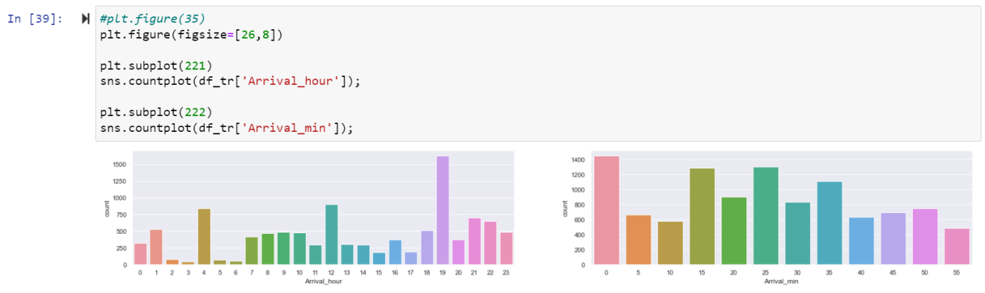

Univarient analysis of ‘Arrival\_hour’ and ‘Arrival\_min’ column in train dataset.

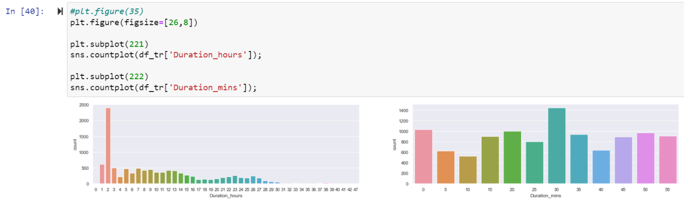

Univarient analysis of ‘Duration\_hours’ and ‘Duration-min’ column in train dataset.

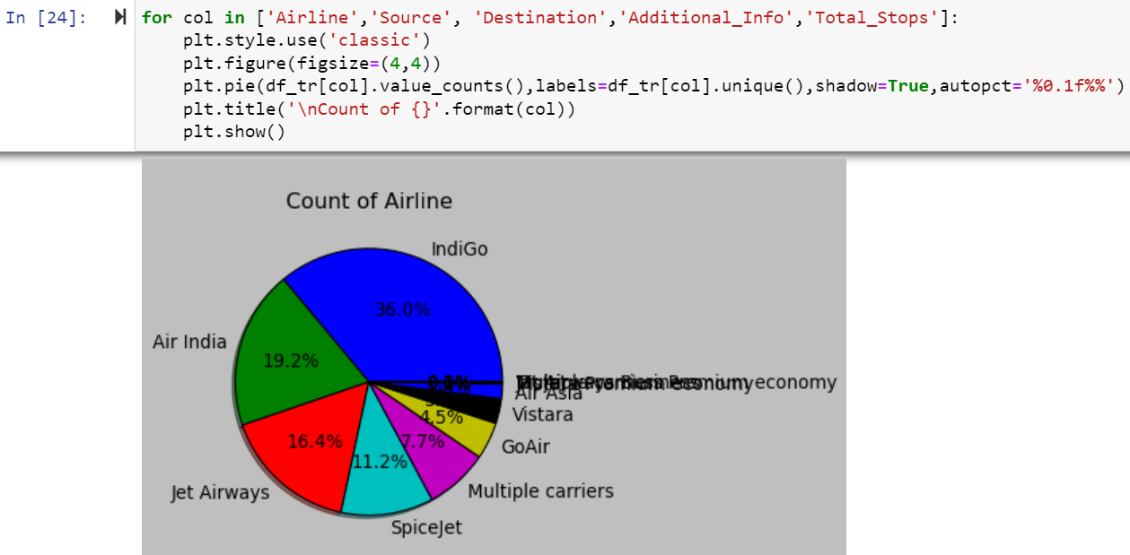

Here pie plot of four columns in Train dataset.

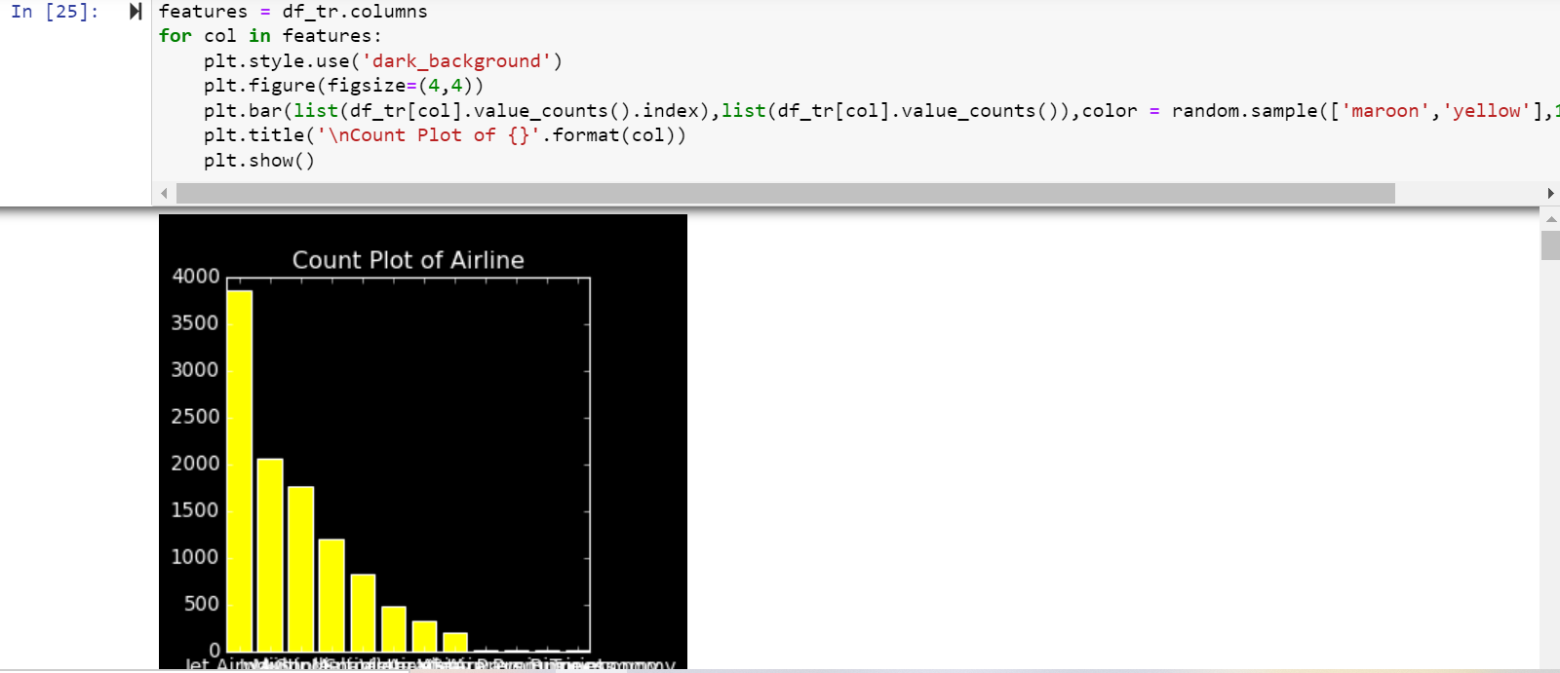

Here barplot of the columns in Train Dataset.

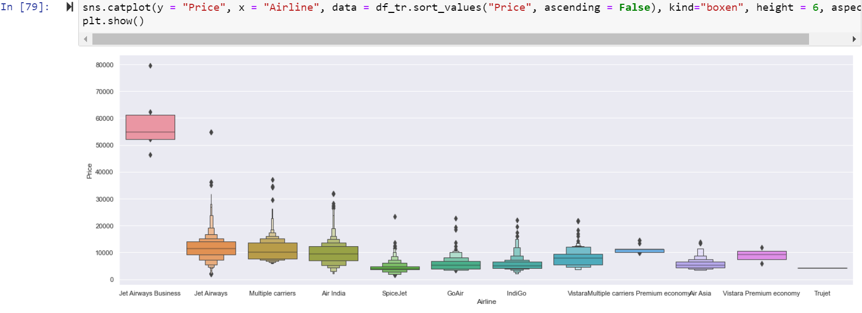

Here above are the plot the target variable Price with the Airline columns and above is the conclusion is Jet Airways Business flight and Jet Airways is expensive than the Indigo and other flights.

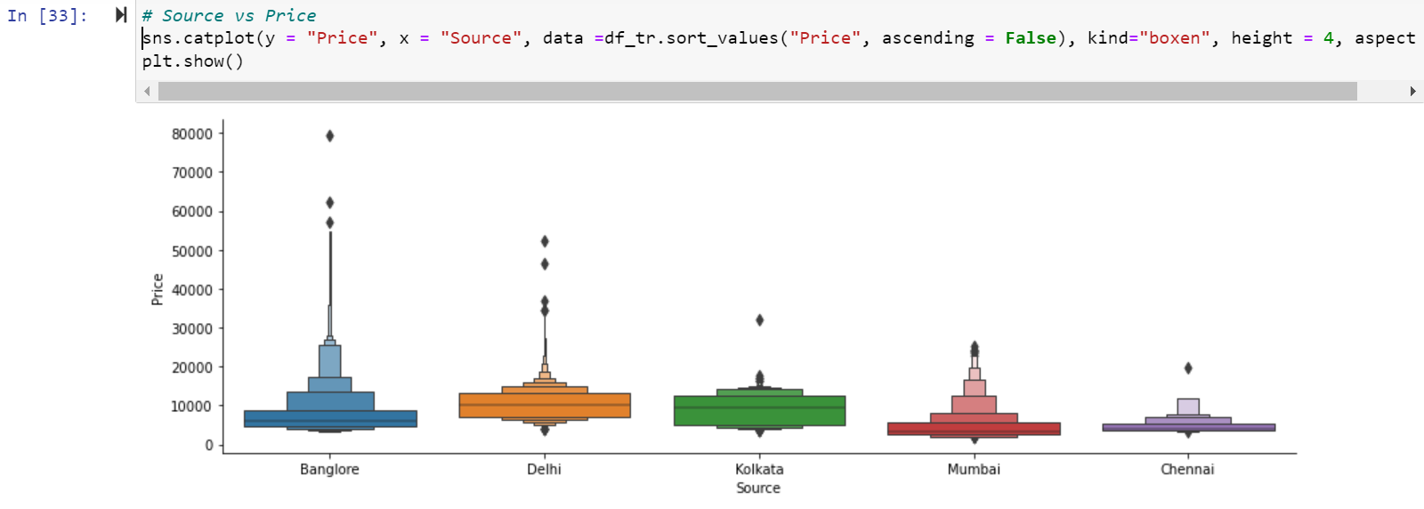

Here above are the plot the target variable Price with the Source columns and above is the conclusion is Bangalore flight is expensive than the other flights.

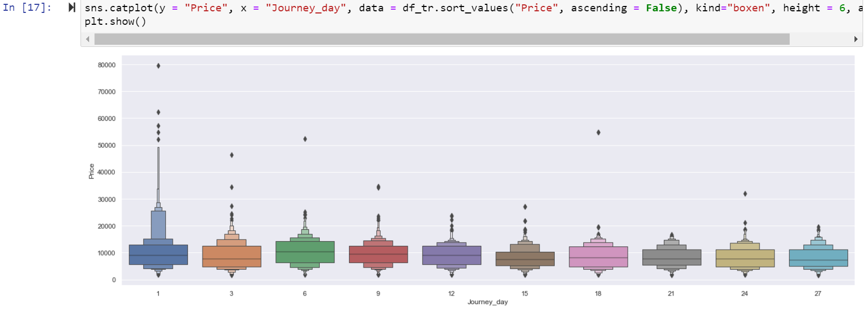

Here above are the plot the target variable Price with the Journey\_day columns and above is the conclusion is day 1 flight is expensive than the other flights.

**Univarient Analysis of Test dataset**:

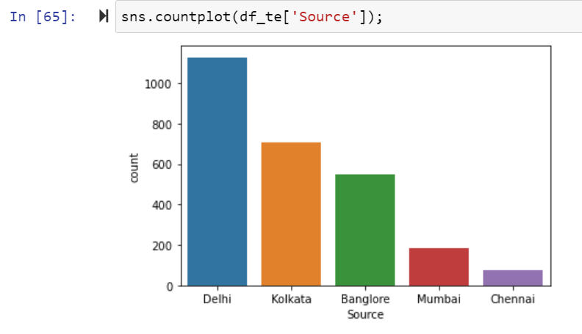 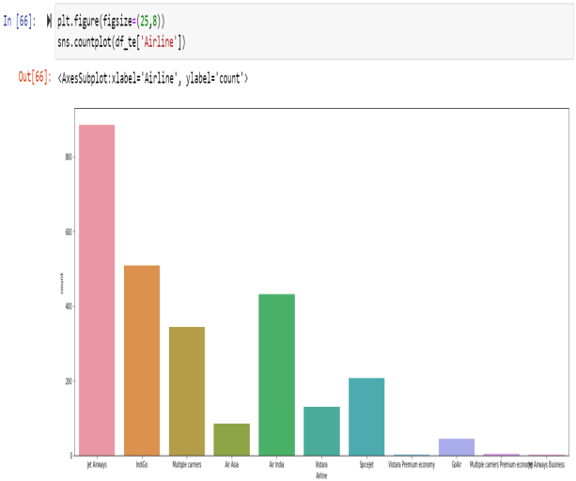

Univarient analysis of ‘Source’ and ‘Airline’ column

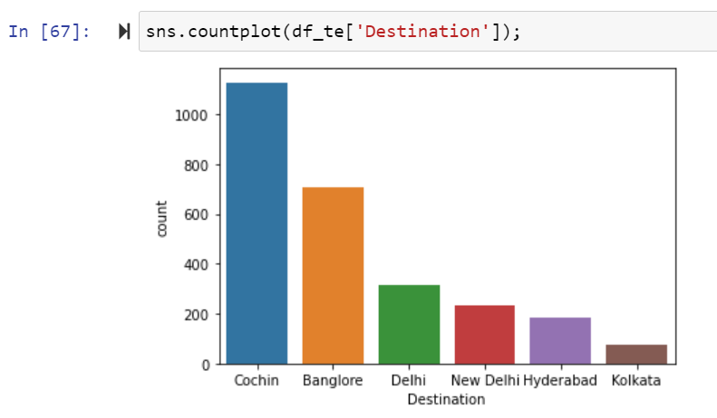 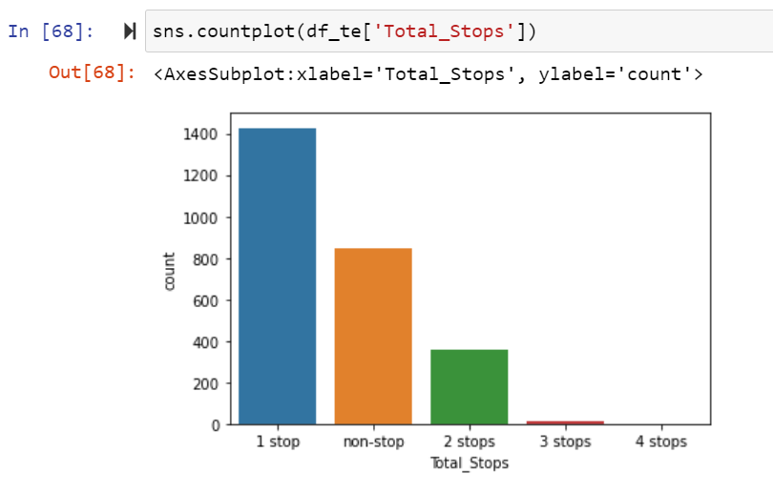

Univarient analysis of ‘Destination’ and ‘Total\_Stops’ column

**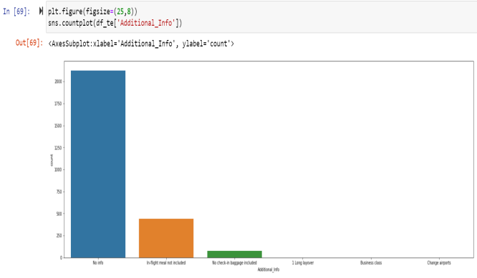**

Univarient analysis of ‘Additional\_Info’ column

**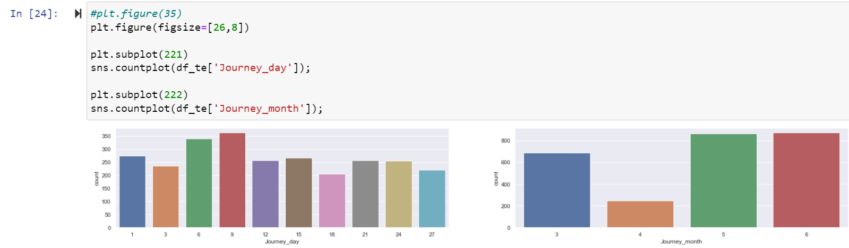**

Univarient analysis of ‘Journey\_day’ and ‘Journey\_month’ column.

**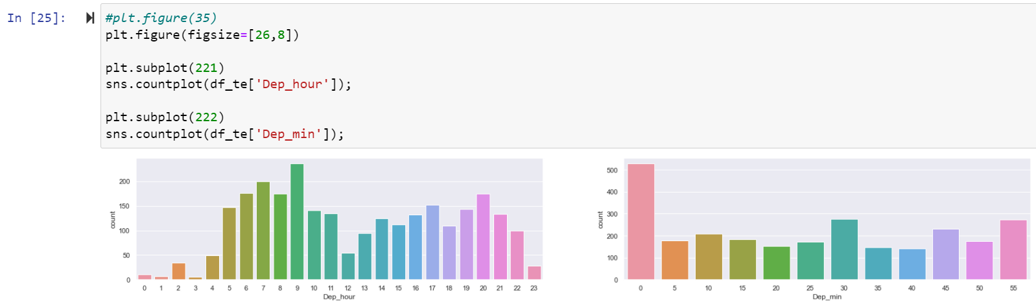**

Univarient analysis of ‘Dep\_hour’ and ‘Dep-min’

**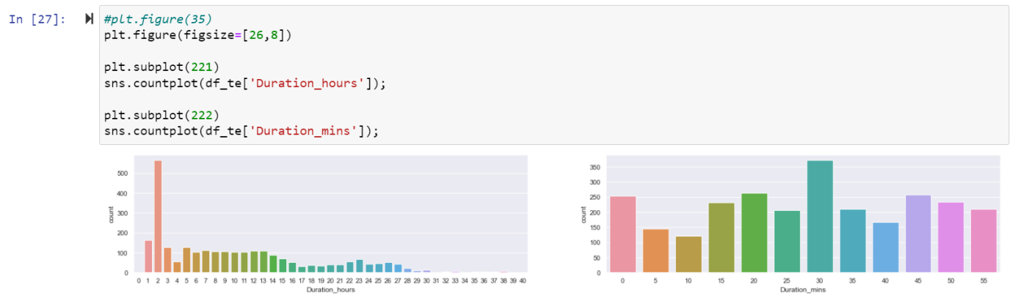**

Univarient analysis of ‘Duration\_hours’ and ‘Duration-min’ column

**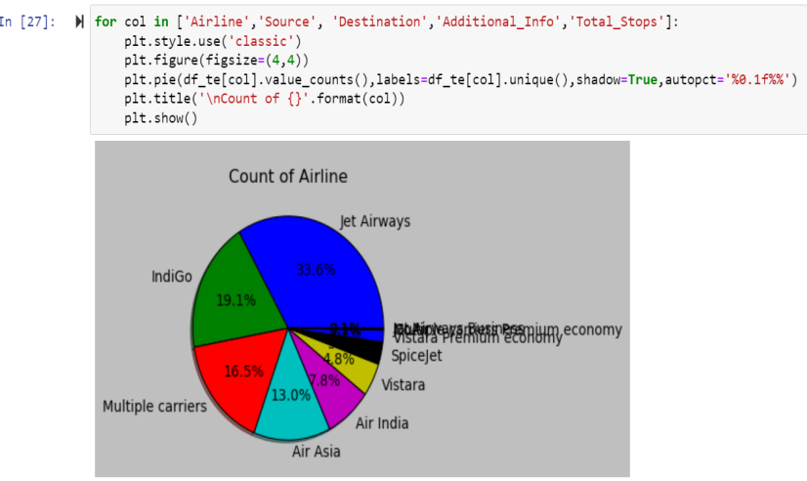**

Here pie plot of four columns in Test dataset.

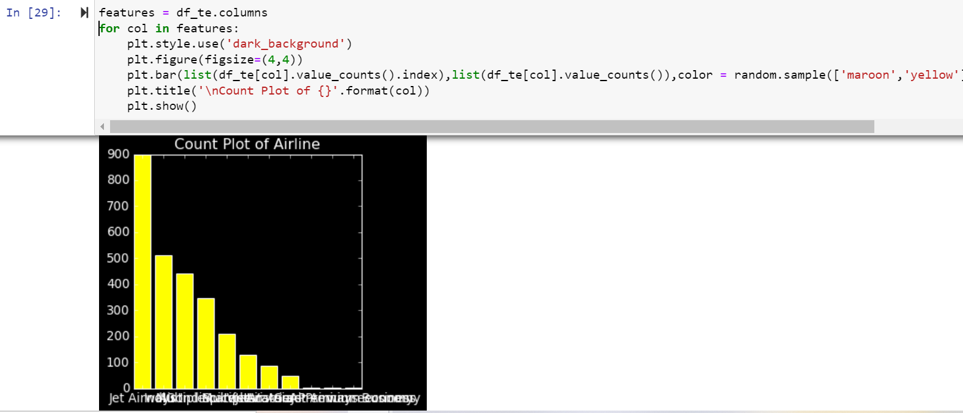

Here barplot of the columns in Test Dataset.

**Checking Distribution of Train Dataset:**

We will now make a **distribution plot** of the math score of the students. A distribution plot tells us how the data is distributed. We will use the distplot function.

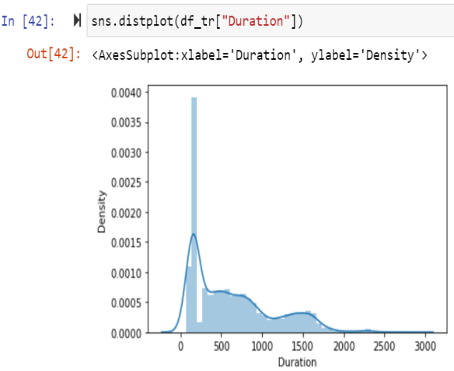 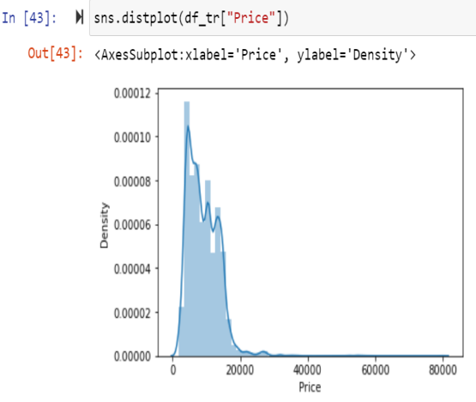

**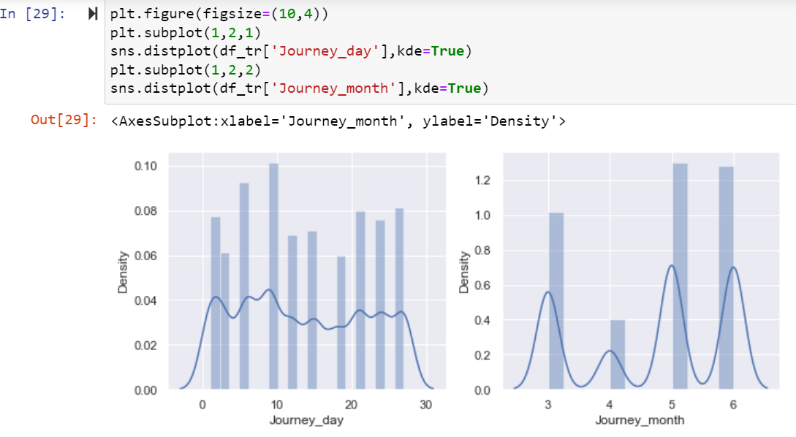**

**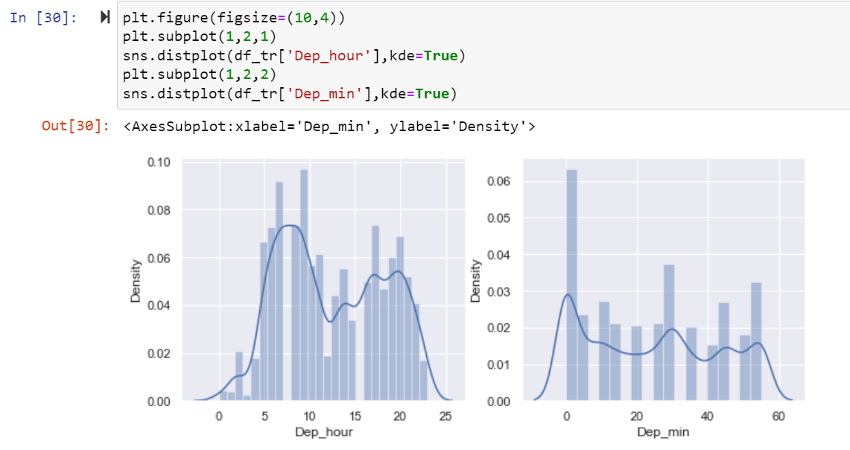**

**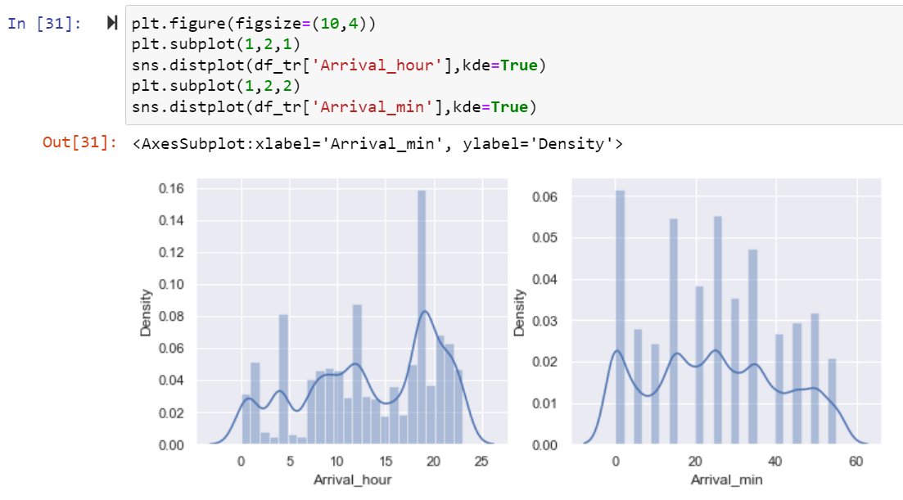**

**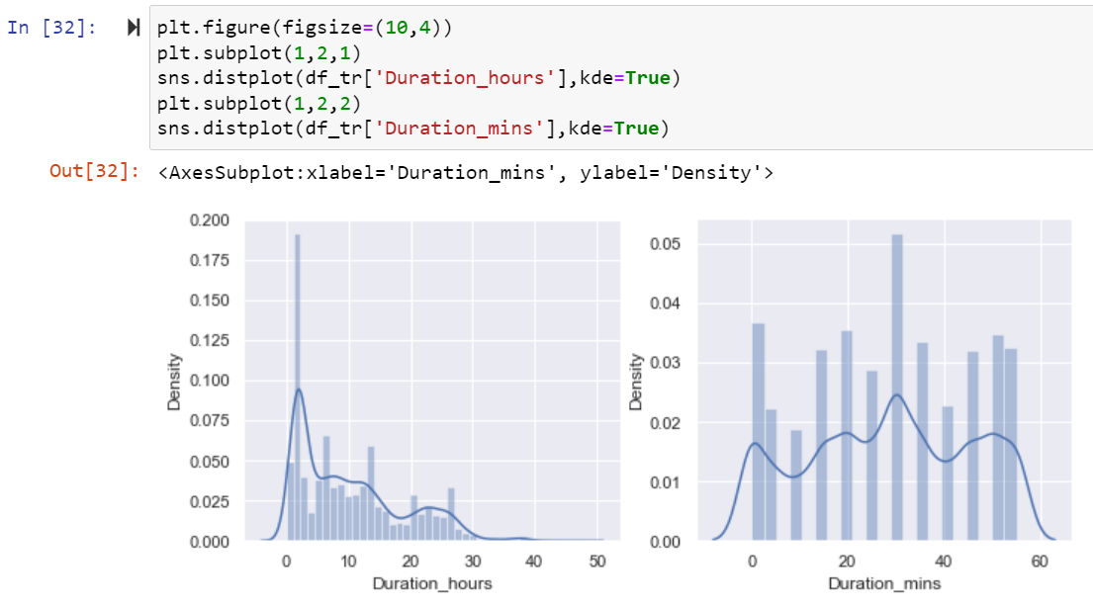**

Here data some column is normally distributed and some column are not normally distributed.

**Checking Outliers of Train Dataset:**

An outlier is an **object(s) that deviates significantly from the rest of the object collection**. It is an abnormal observation during the Data Analysis stage, that data point lies far away from other values. An outlier is an observation that diverges from well-structured data.

**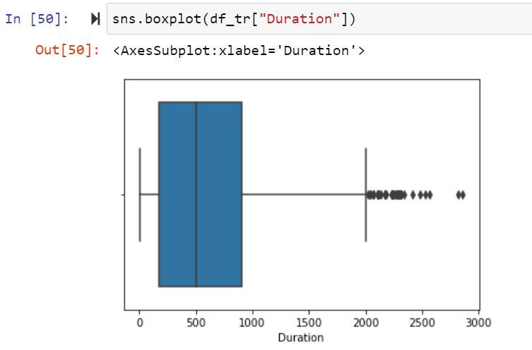** **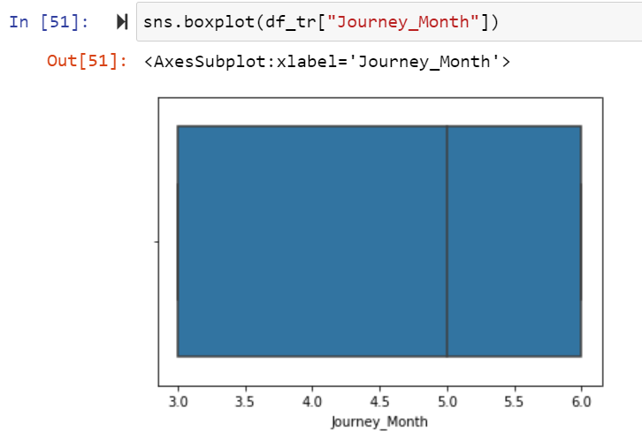**

**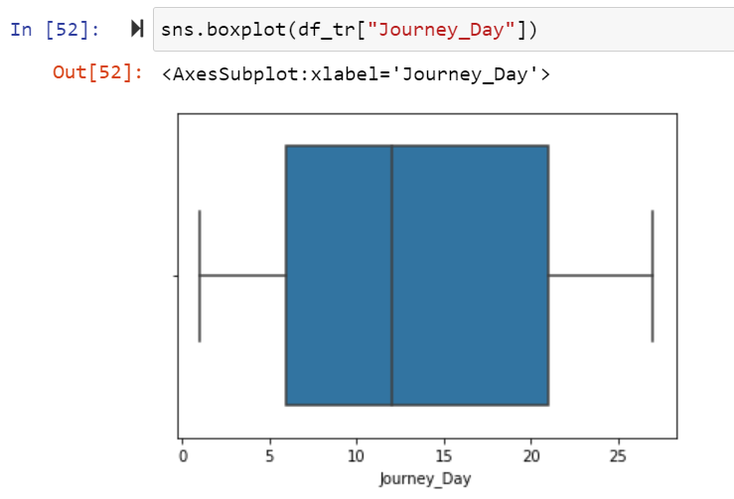** **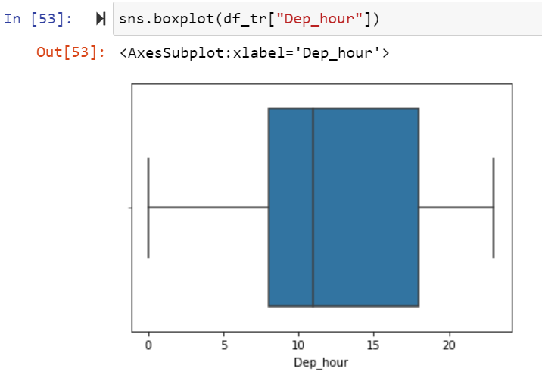**

**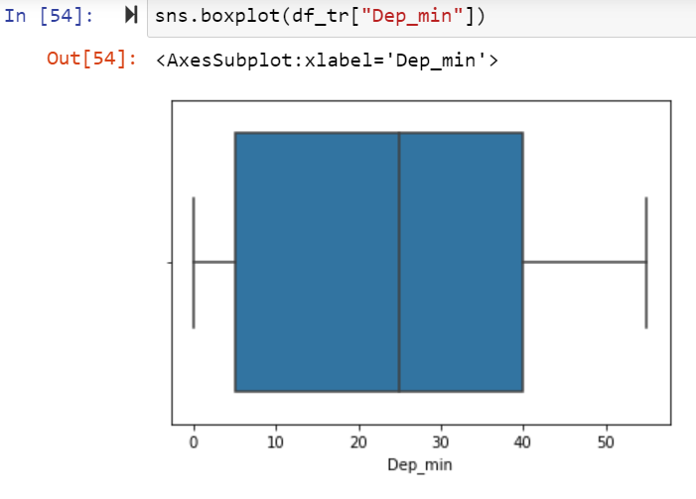**  **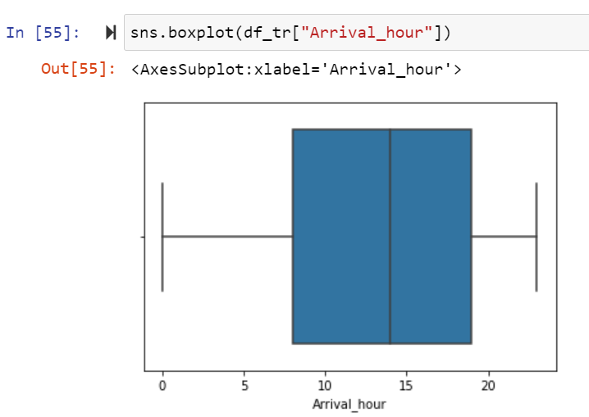**

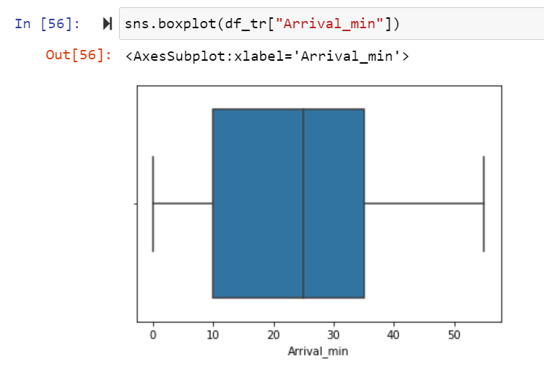

**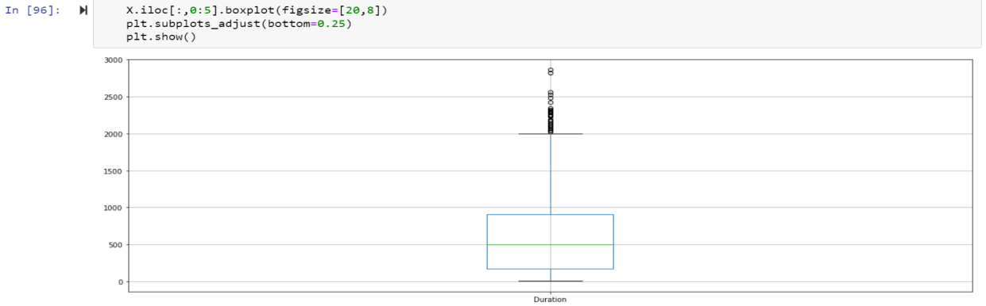**

**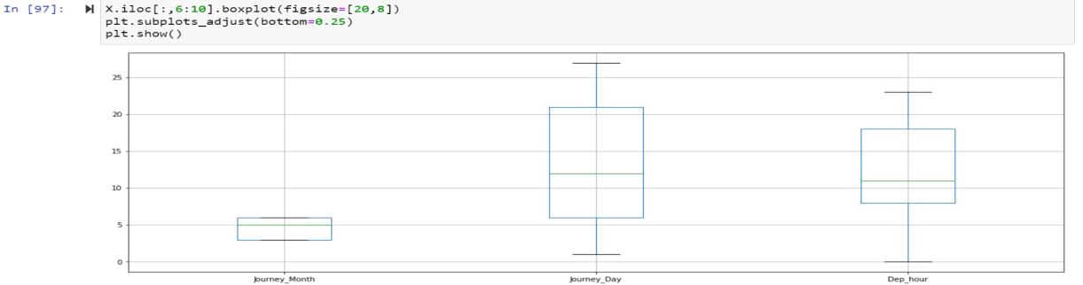**

**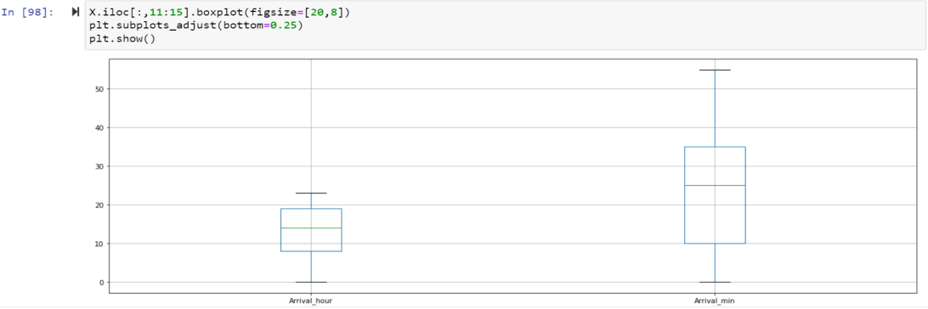**

Here Duration Column outliers are present in Train dataset.

**Checking Distribution of Test Dataset:**

**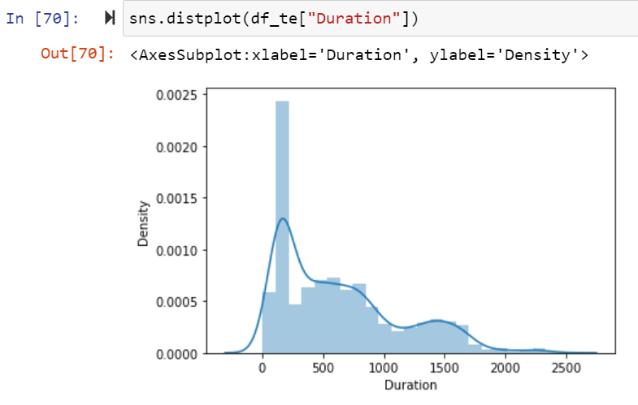**

**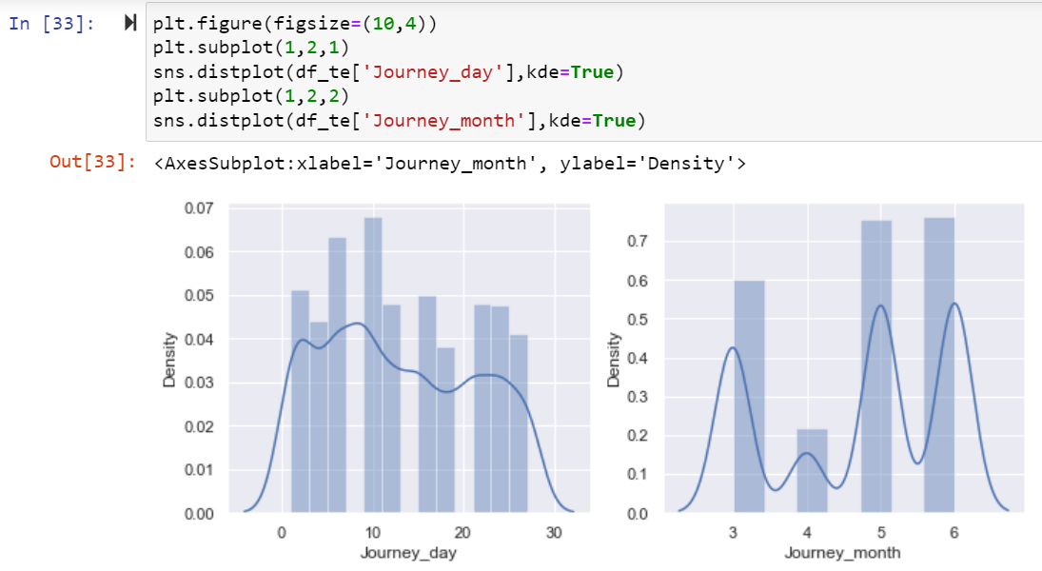**

**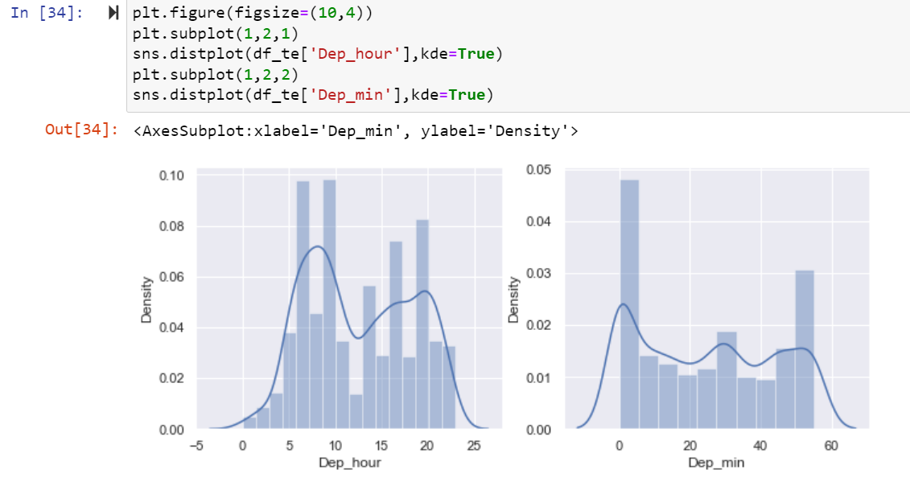**

**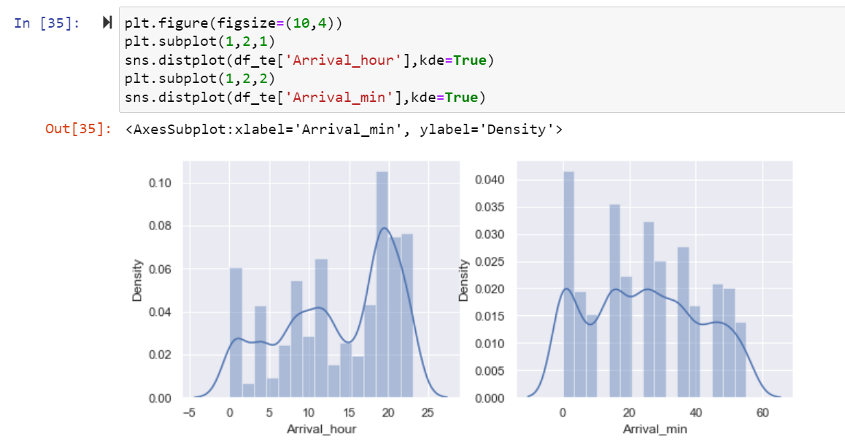**

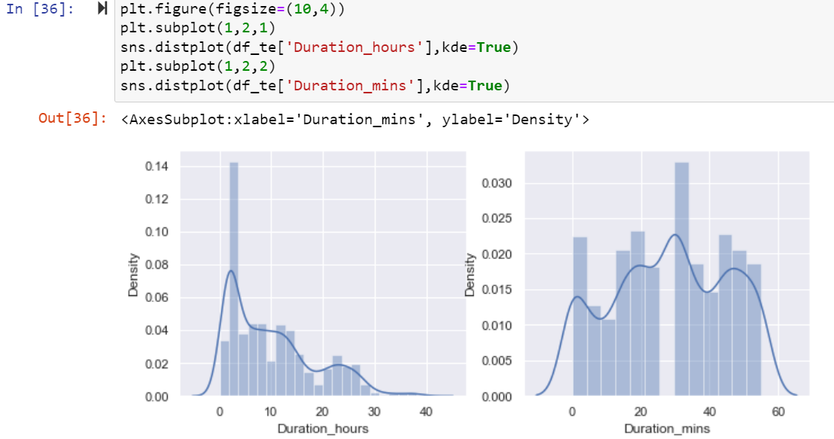

Here data some column is normally distributed and some column are not normally distributed.

**Checking Outliers of Test Dataset:**

**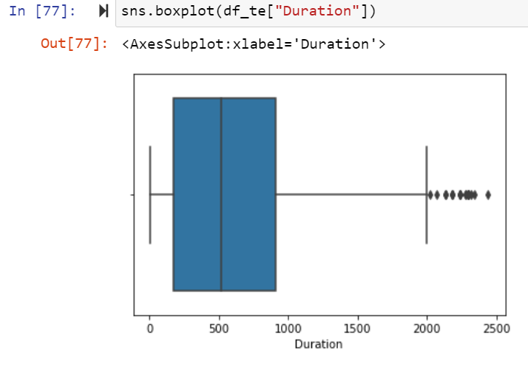**  **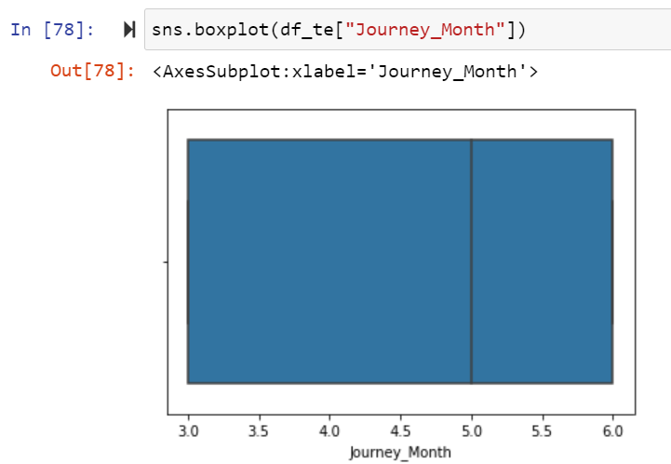**

**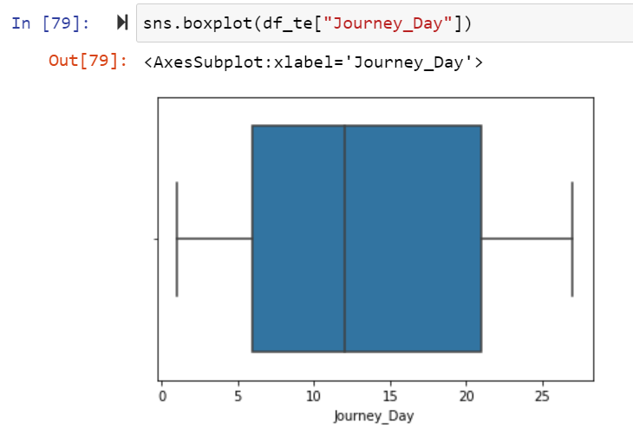**  **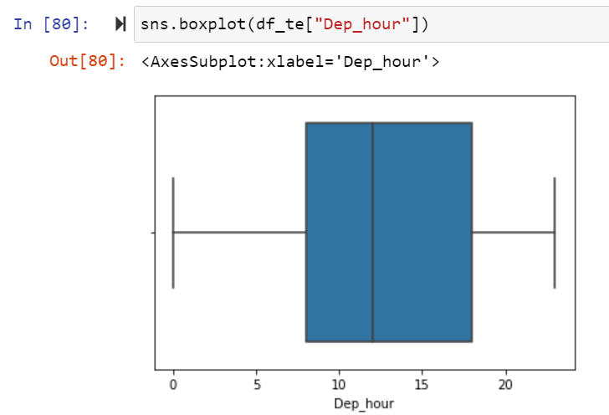**

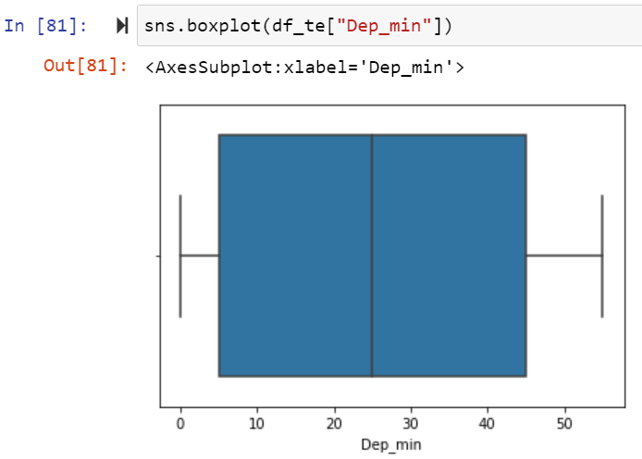 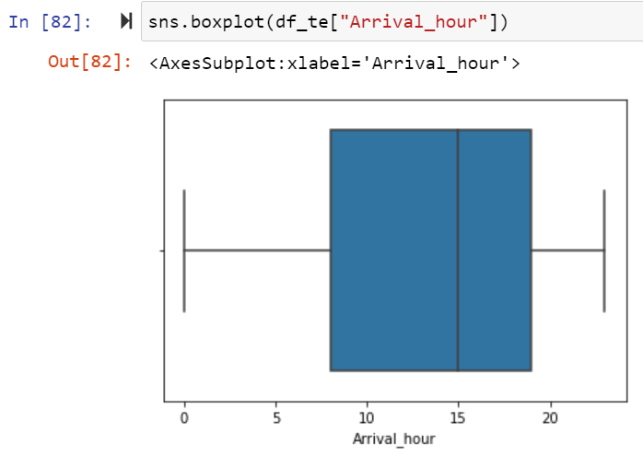

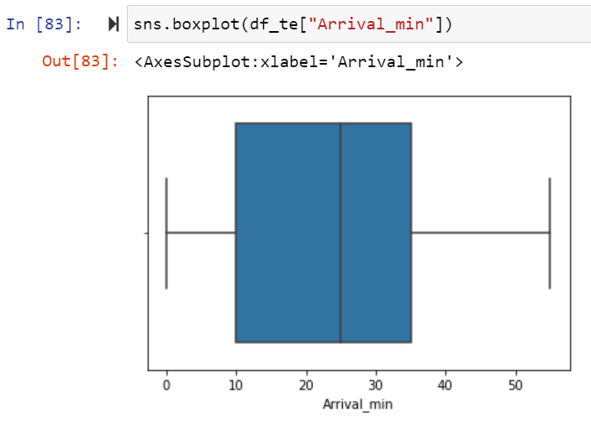

Here Duration Column outliers are present in Test dataset.

**Bi varient Analysis of Train Dataset:**

#### Scatter Plot

A scatter plot represents individual pieces of data using dots. These plots make it easier to see if two variables are related to each other. The resulting pattern indicates the type (linear or non-linear) and strength of the relationship between two variables.

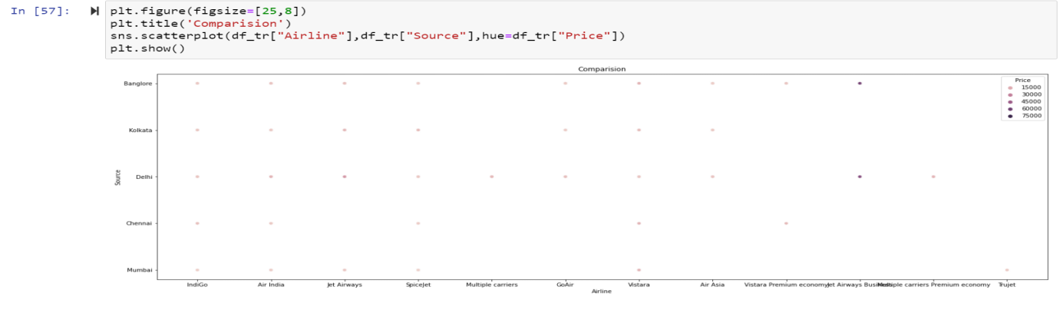

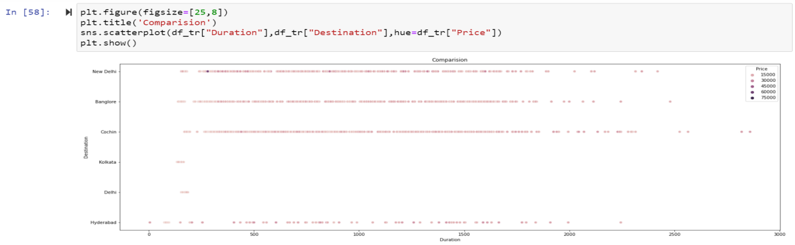

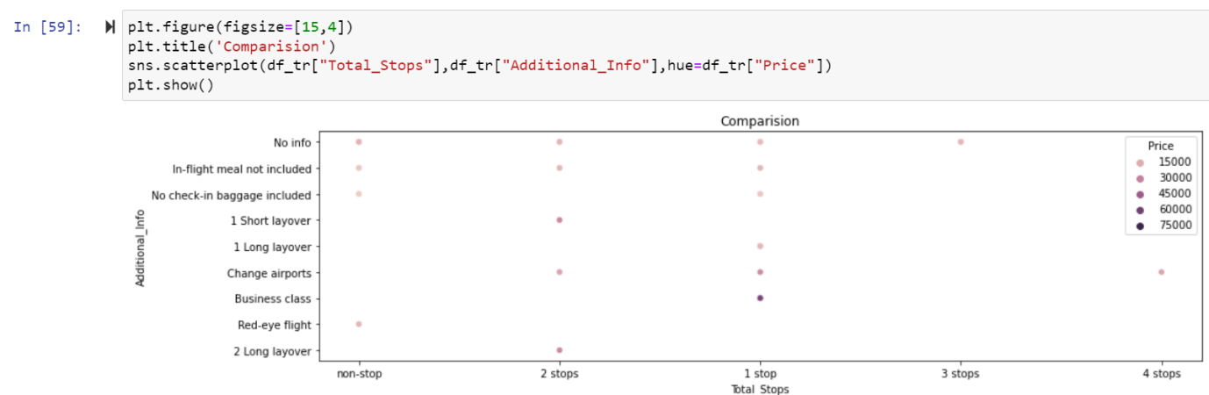

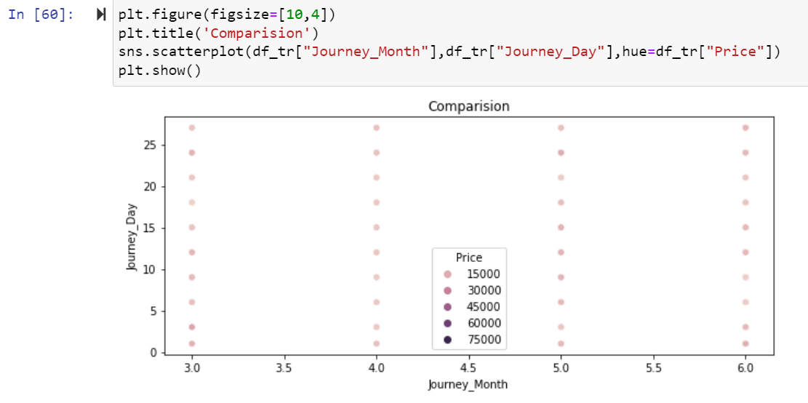

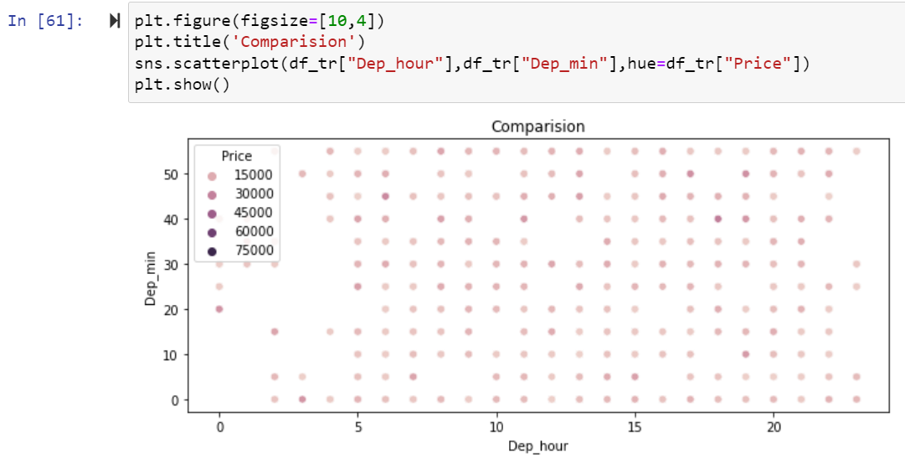

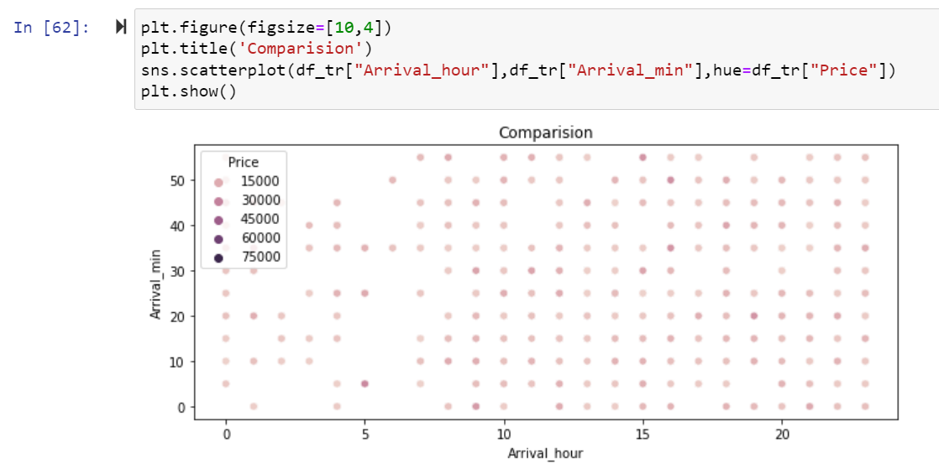

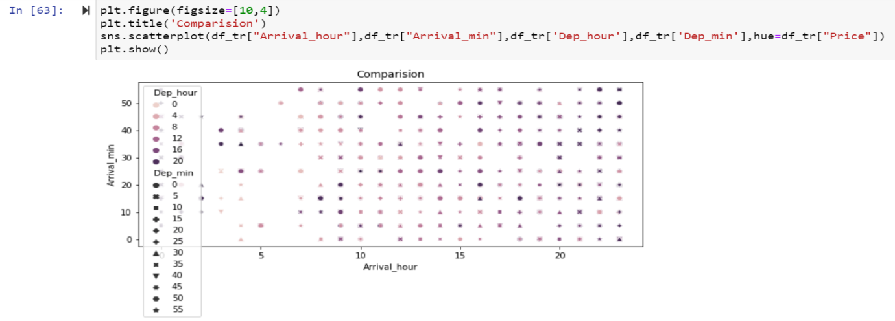

Here Above Scatterplot shows the comparision between two columns In which hue Target column Train Dataset.

**Bi varient Analysis of Test Dataset:**

#### Scatter Plot

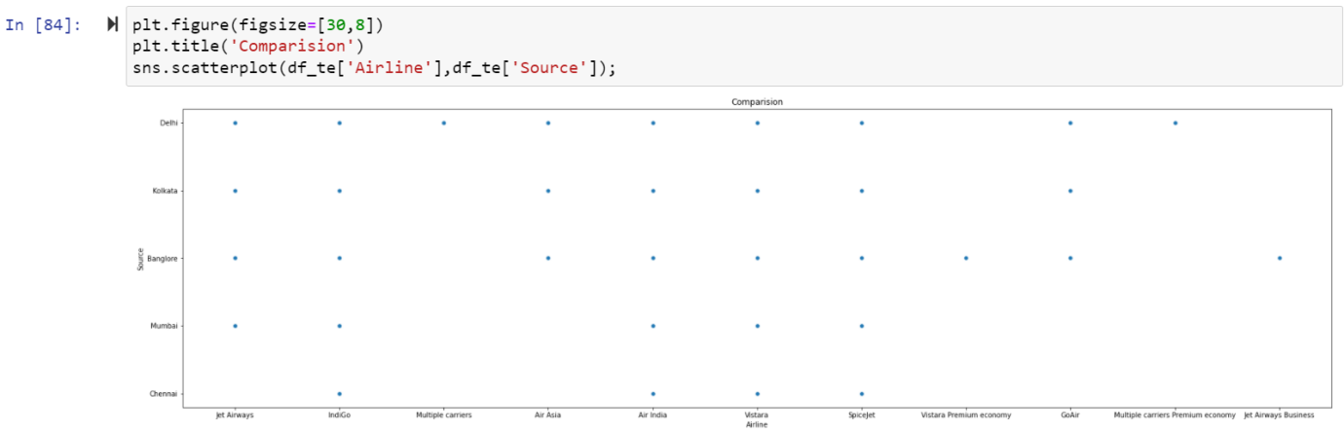

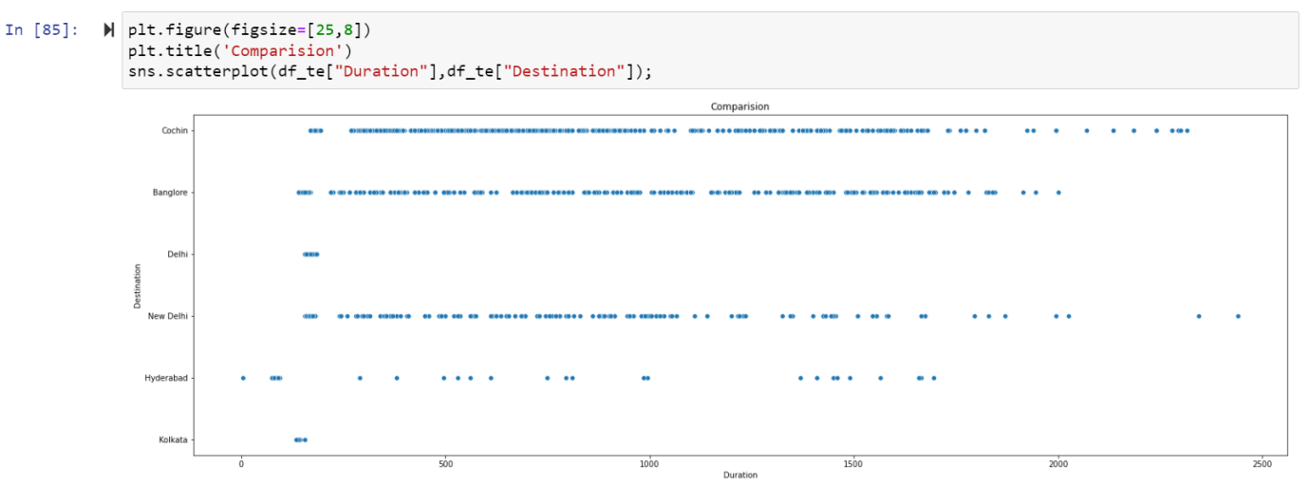

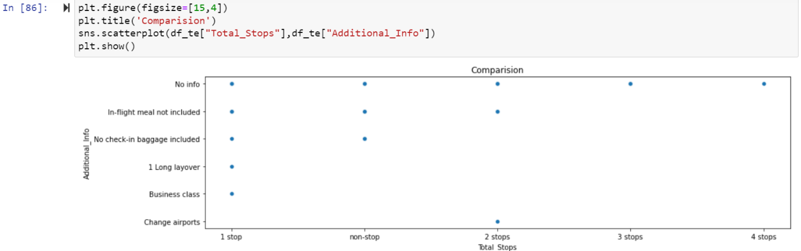

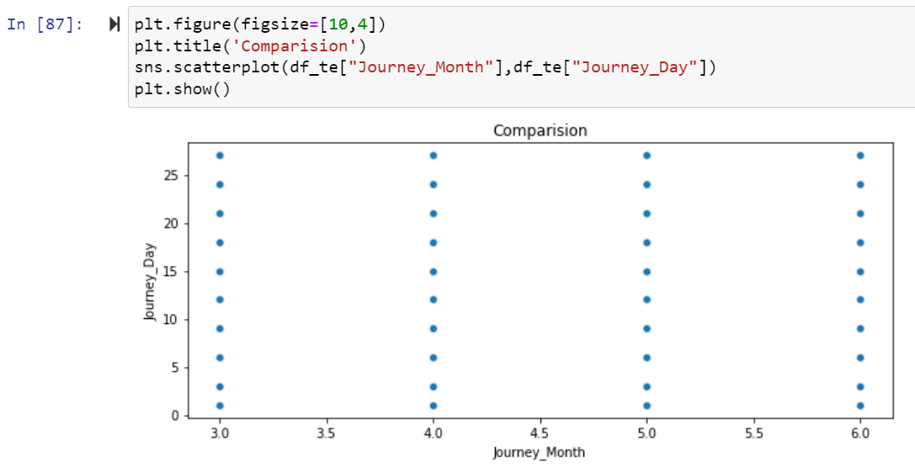

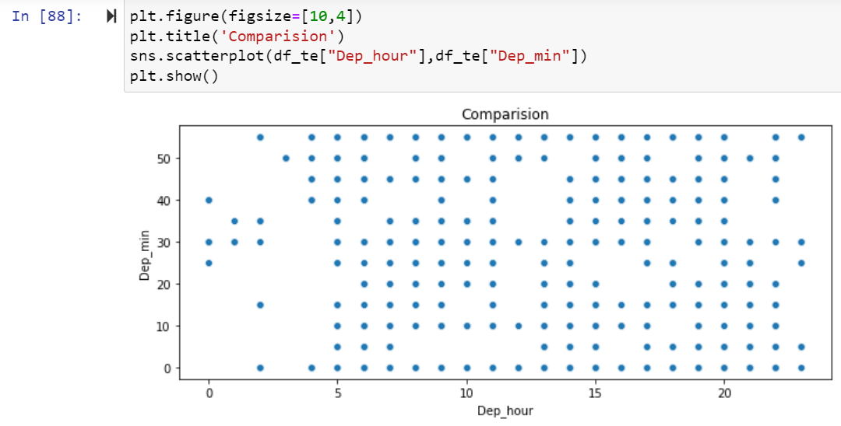

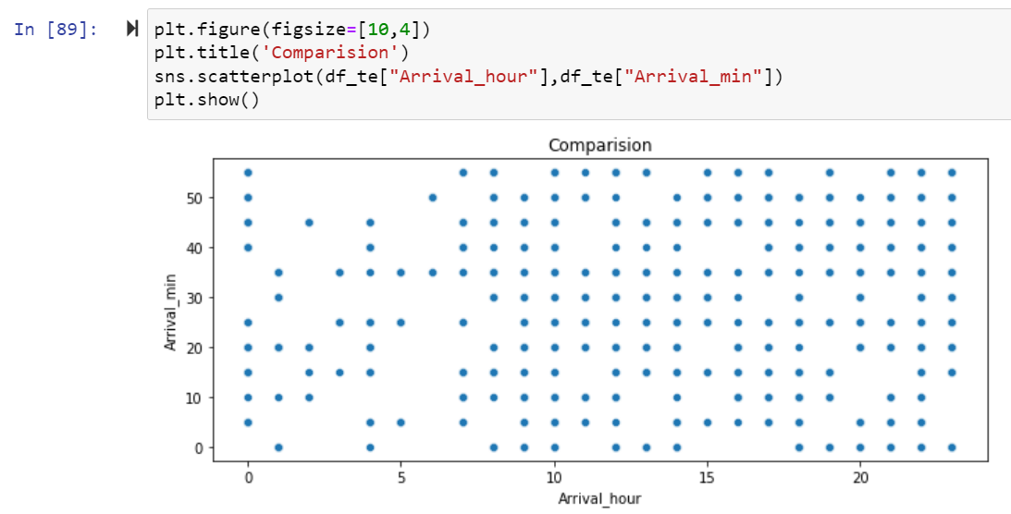

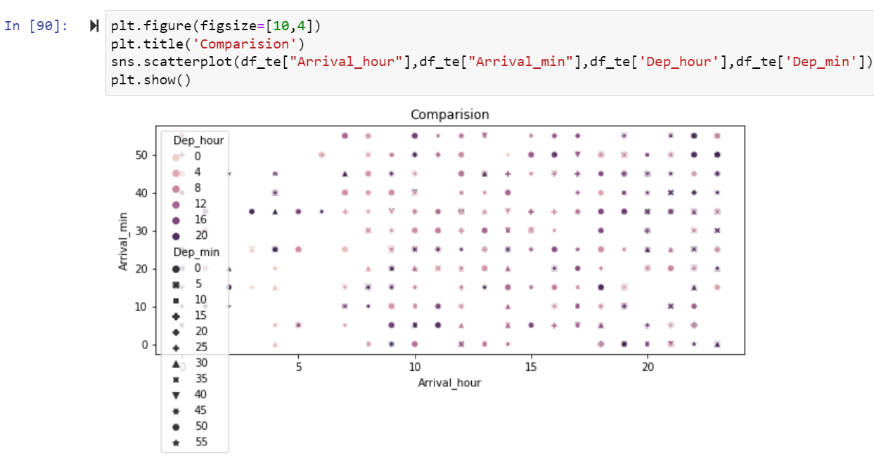

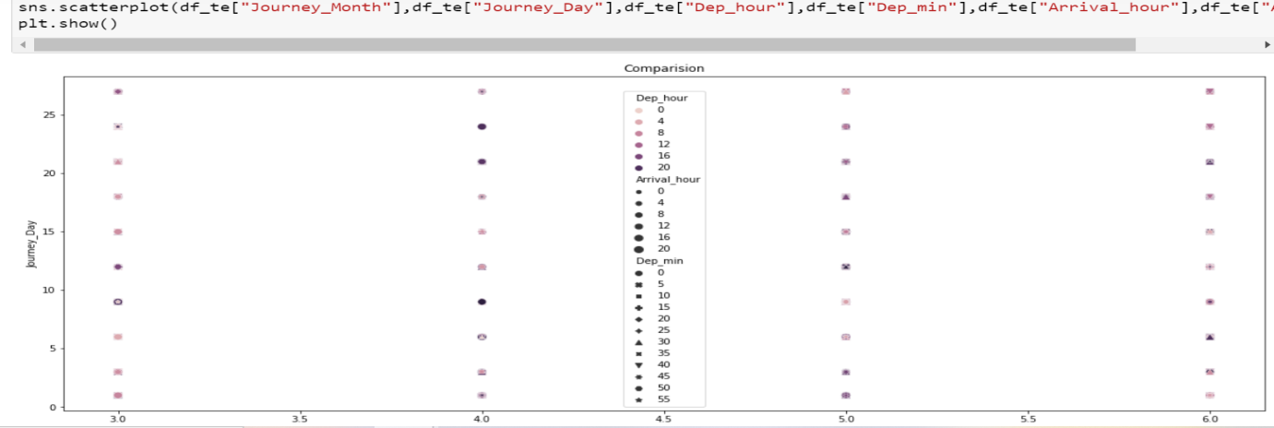

Here Above Scatterplot shows the comparision between two columns In which hue Target column Test Dataset.

**Multi Varient Analysis of Train Dataset:**

Multivariate analysis is used **to study more complex sets of data than what univariate analysis methods can handle**. ... Multivariate analysis can reduce the likelihood of Type errors. Sometimes, univariate analysis is preferred as multivariate techniques can result in difficulty interpreting the results of the test.

**PairPlot Hue Target column in Train Dataset**:

Pairplot **visualizes given data to find the relationship between them where the variables can be continuous or categorical**. Plot pairwise relationships in a data-set. Pairplot is a module of seaborn library which provides a high-level interface for drawing attractive and informative statistical graphics.

**sns.pairplot(df\_tr, hue='Price')**

**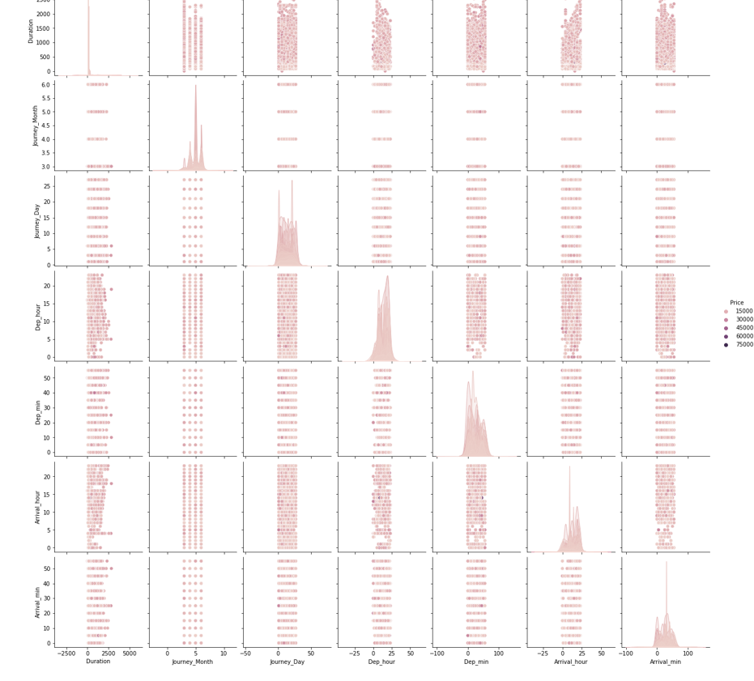**

**Multi Varient Analysis of Test Dataset:**

**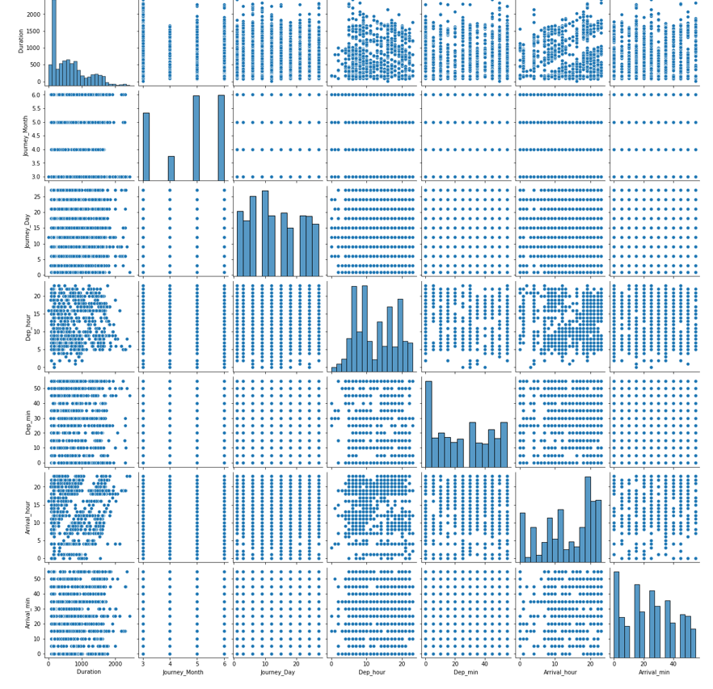**

**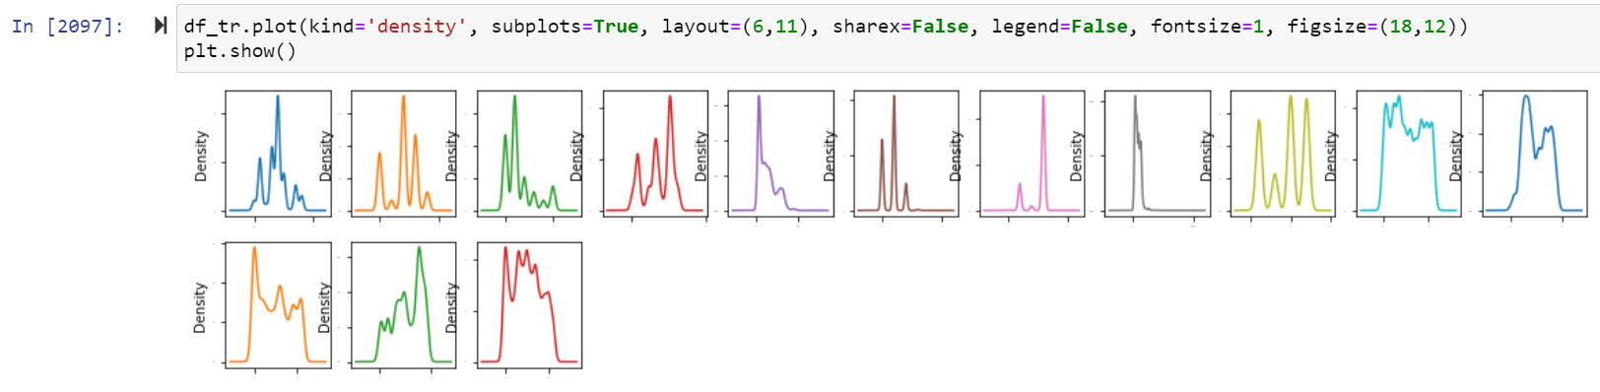**

Here distribution of all columns in Train Dataset.

**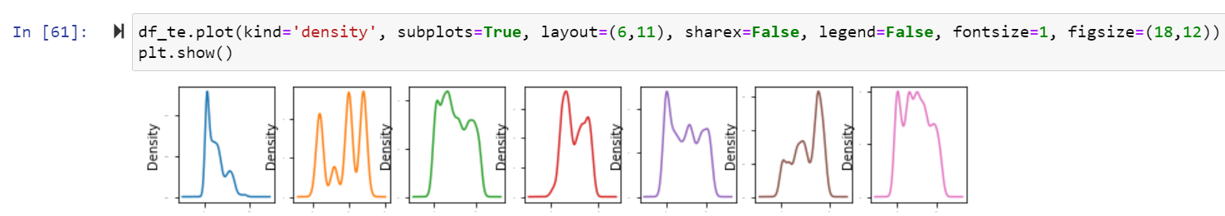**

Here distribution of all columns in Test Dataset.

**Data Inputs- Output Logic- Relationships**

Describe the relationship behind the data input, its format, the logic in between and the output. Describe how the input affects the output.



Here Change the values in Total\_Stops column in Train and Test Dataset.

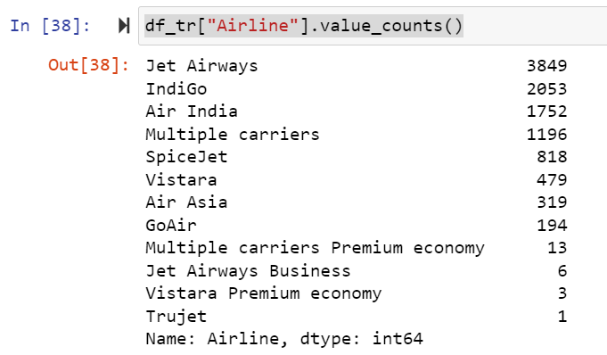

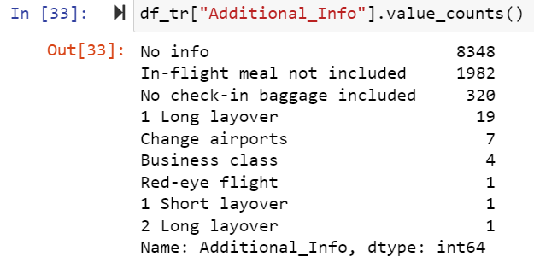

Here Check the values in Airline and Additional Info column in Dataset.

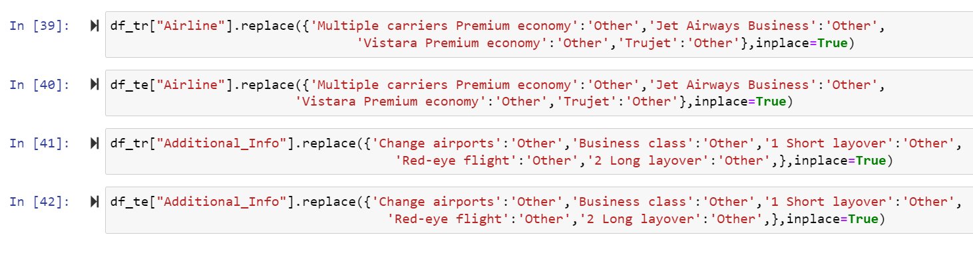

Here Change the values in Airline and Additional\_Info column in Train and Test Dataset.’

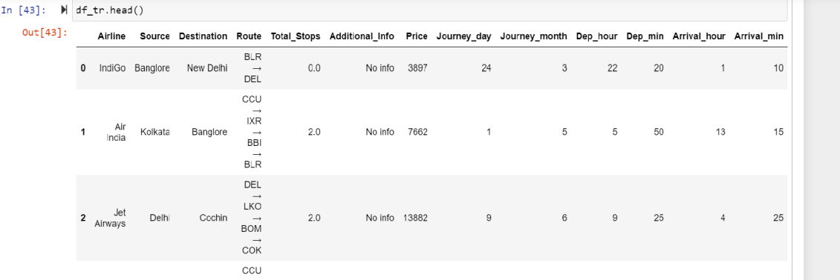

After that display Train dataset.

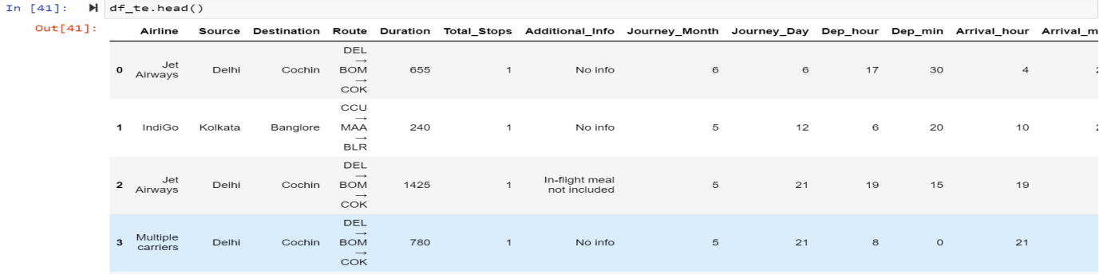

After that display Test dataset.

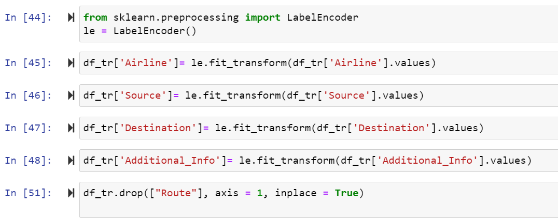

Here use label encoder to replace the categorical values into numeric in train dataset and drop the Route column because it is not much important.

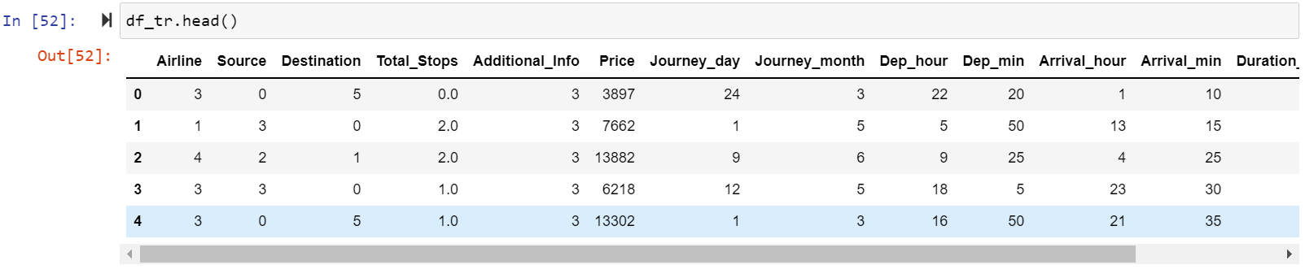

Here after converting categorical values into numeric display Train Dataset.

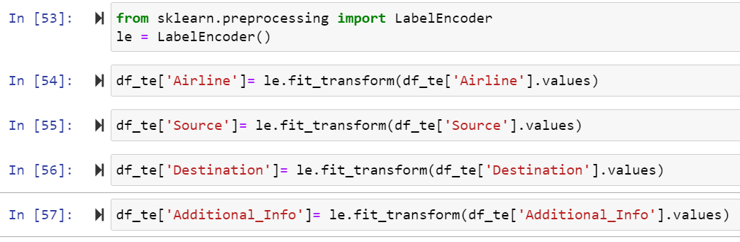

Here use label encoder to replace the categorical values into numeric in Test dataset and drop the Route column because it is not much important.

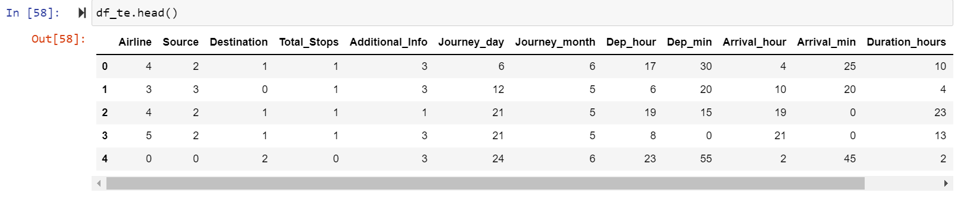

Here after converting categorical values into numeric display Test Dataset.

**State the set of assumptions (if any) related to the problem under consideration**

This study aims to analyse the accuracy of predicting house prices when using Multiple linear, Lasso, Ridge, Random Forest regression algorithms and Artificial neural network (ANN). Thus, the purpose of this study is to deepen the knowledge in regression methods in machine learning. In addition, the given datasets should be processed to enhance performance, which is accomplished by identifying the necessary features by applying one of the selection methods 2 to eliminate the unwanted variables since each house has its unique features that help to estimate its price. These features may or may not be shared with all houses, which means they do not have the same influence on the house pricing resulting in inaccurate output.

**Hardware and Software Requirements and Tools Used**

1. Software Requirements:

* 1. Coding Language: Python3, Python
  2. Coding software : Anaconda, Jupyter Notebook

1. Microsoft Office Word.
2. Snipping Tools (For Screenshots).
3. Microsoft Excel

**Non Functional Requirements:**

1: Platform Independent: The application would be platform independent if all the requirements are installed in the device.

2: Performance: The application should have better accuracy and should provide the information in less time.

3: Capacity: The capacity of the storage should be high so that large amount of data can be stored in order to train the model.

**Hardware Requirements:**

1 GB RAM.

200 GB HDD.

Intel 1.66 GHz Processor Pentium 4

Here, you can describe any presumptions taken by you.

**Visualizations:**

**Heatmap of Train Dataset:**

cor=df\_tr.corr()

cor

**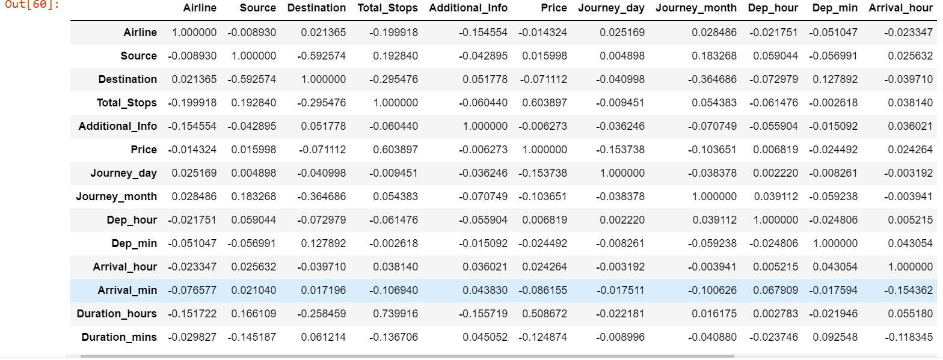**

After that Checking Correlation of all independent columns with Target column.

plt.figure(figsize=(15,10))

sns.heatmap(df\_tr.corr(),annot=True)

**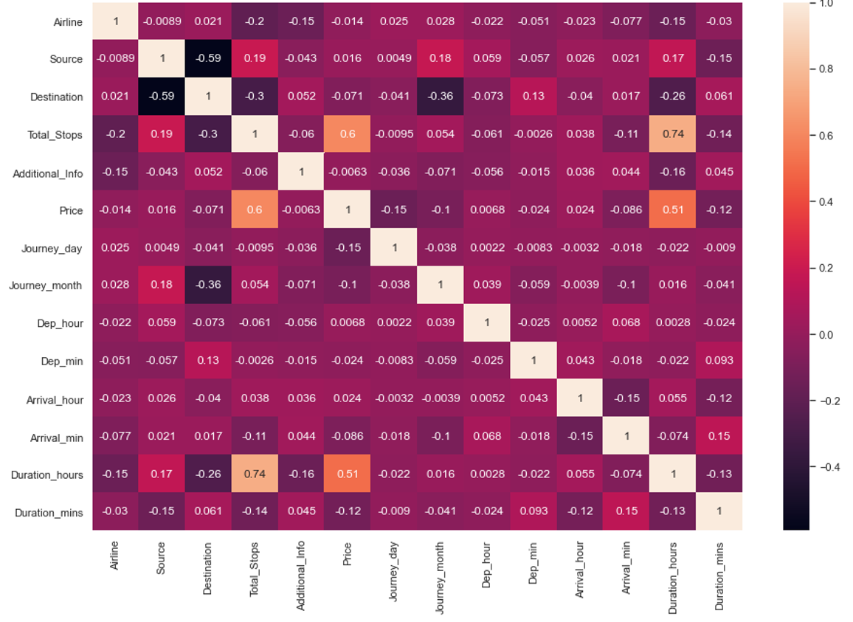**

Heat map shows the correlation of every independent variable in dataset with target variable. Here above heatmap the every independent variable check correlation with Price target variable.

plt.figure(figsize=(15,10))

df\_tr.corr()['Price'].sort\_values(ascending=False).drop(['Price']).plot(kind='bar',color='c')

plt.xlabel('Feature',fontsize=14)

plt.ylabel('column with target names',fontsize=14)

plt.title('correlation',fontsize=18)

plt.show()

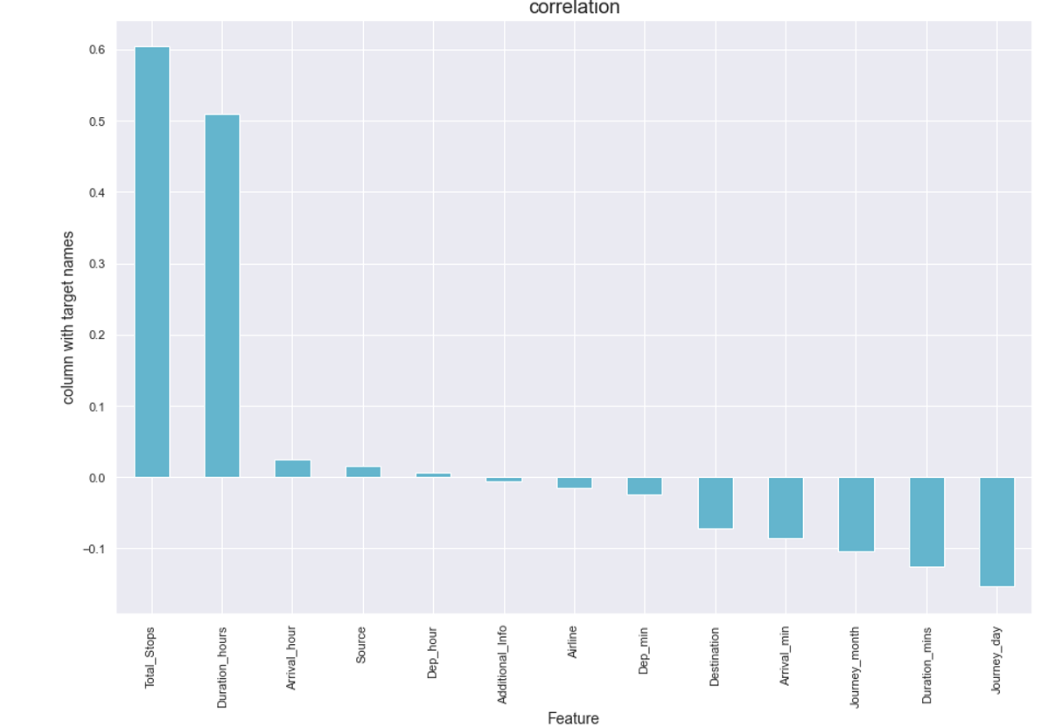

Here we shows the correlation in another way in this above we show some columns are positively and some columns are negatively correlated with target variable.

**Heatmap of Test Dataset:**

cor=df\_te.corr()

cor

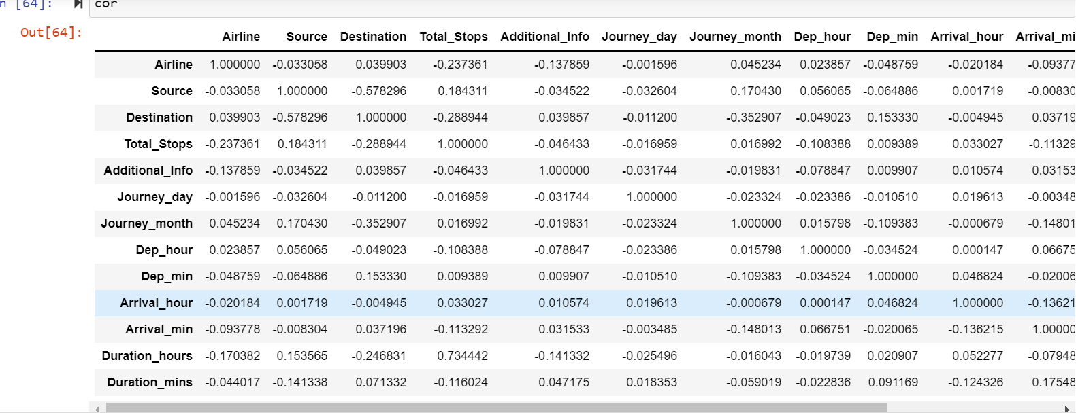

After that Checking Correlation of all independent columns in Test Dataset.

plt.figure(figsize=(15,10))

sns.heatmap(df\_tr.corr(),annot=True)

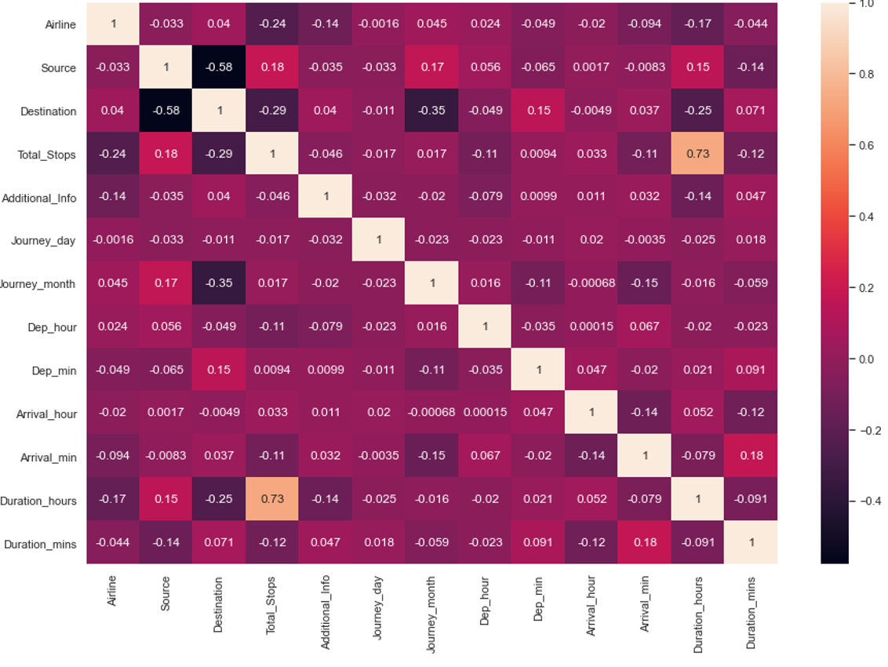

Heat map shows the correlation of every independent variable in dataset with target variable. Here above heatmap the every independent variable check correlation.

**State the set of assumptions (if any) related to the problem under consideration:**

In this we analyse the accuracy of predicting house prices when using Multiple linear, Lasso, Ridge, Random Forest regression algorithms. Thus, the purpose of this is to depend the knowledge in regression methods in machine learning. In addition, the given datasets should be processed to enhance performance, which is accomplished by identifying the necessary features by applying one of the selection methods 2 to eliminate the unwanted variables since each house has its unique features that help to estimate its price. These features may or may not be shared with all houses, which means they do not have the same influence on the house pricing resulting in inaccurate output.

**Z-score:**

Take your data point, subtract the mean from the data point, and then divide by your standard deviation. That gives you your Z-score. You can use Z-Score to determine outliers.One of the most commonly used tools in determining outliers is the Z-score. Z-score is just the number of standard deviations away from the mean that a certain data point is.In your future data science life, Z-scores are gonna be a really useful way to think about how usual or how unusual a certain data point is. And that’s going to be really valuable once we start making inferences based on our data. In this story, we will take a deep dive into our notebooks and learn how to detect outliers using Z-Score.

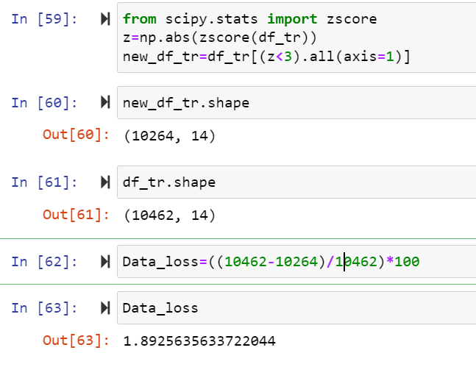

After that Cheking Data loss of the dataset after using preprocessing steps here using zscore method checking dataloss here after zscore there 1.89 is dataloss.

**IQR:**

The interquartile range rule is useful in detecting the presence of outliers. [Outliers](https://www.thoughtco.com/what-is-an-outlier-3126227) are individual values that fall outside of the overall pattern of a data set. This definition is somewhat vague and subjective, so it is helpful to have a rule to apply when determining whether a data point is truly an outlier—this is where the interquartile range rule comes in.

## What Is the Interquartile Range?

Any set of data can be described by its [five-number summary](https://www.thoughtco.com/what-is-the-five-number-summary-3126237). These five numbers, which give you the information you need to find patterns and outliers, consist of (in ascending order):

* The minimum or lowest value of the dataset
* The first quartile Q1, which represents a quarter of the way through the list of all data
* The [median](https://www.thoughtco.com/what-is-the-median-3126370) of the data set, which represents the midpoint of the whole list of data
* The third quartile Q3, which represents three-quarters of the way through the list of all data
* The maximum or highest value of the data set.

These five numbers tell a person more about their data than looking at the numbers all at once could, or at least make this much easier. For example, the [range](https://www.thoughtco.com/what-is-the-range-in-statistics-3126248), which is the minimum subtracted from the maximum, is one indicator of how spread out the data is in a set (note: the range is highly sensitive to outliers—if an outlier is also a minimum or maximum, the range will not be an accurate representation of the breadth of a data set).

Range would be difficult to extrapolate otherwise. Similar to the range but less sensitive to outliers is the interquartile range. The [interquartile range](https://www.thoughtco.com/what-is-the-interquartile-range-3126245) is calculated in much the same way as the range. All you do to find it is subtract the first quartile from the third quartile:

IQR = Q3 – Q1.

The interquartile range shows how the data is spread about the median. It is less susceptible than the range to outliers and can, therefore, be more helpful.

## Using the Interquartile Rule to Find Outliers

Though it's not often affected much by them, the interquartile range can be used to detect outliers. This is done using these steps:

1. Calculate the interquartile range for the data.
2. Multiply the interquartile range (IQR) by 1.5 (a constant used to discern outliers).
3. Add 1.5 x (IQR) to the third quartile. Any number greater than this is a suspected outlier.
4. Subtract 1.5 x (IQR) from the first quartile. Any number less than this is a suspected outlier.

Remember that the interquartile rule is only a rule of thumb that generally holds but does not apply to every case. In general, you should always follow up your outlier analysis by studying the resulting outliers to see if they make sense. Any potential outlier obtained by the interquartile

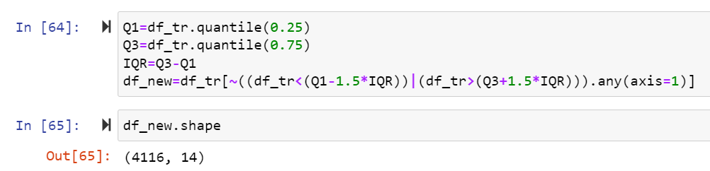

Here After Applying IQR method checking dataloss here using IQR method more dataloss.

**Skewness:**

The skewness is a measure of symmetry or asymmetry of data distribution, and kurtosis measures whether data is heavy-tailed or light-tailed in a normal distribution. Data can be positive-skewed (data-pushed towards the right side) or negative-skewed (data-pushed towards the left side).

**Checking skewness in dataset**

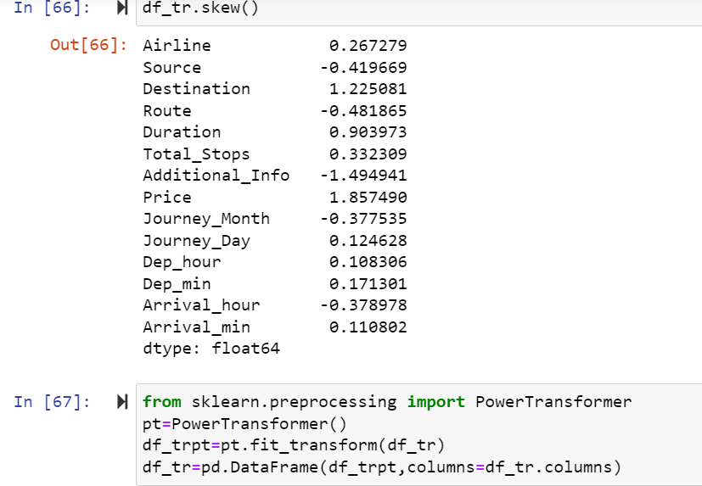

**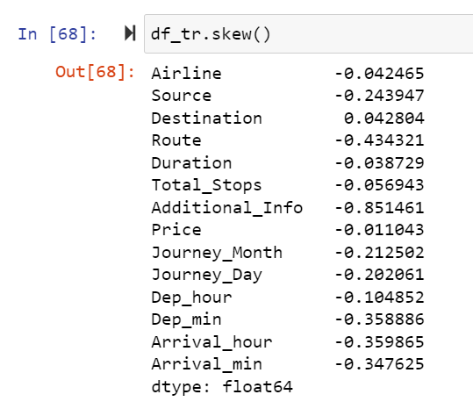**

To remove skewness use PowerTransformer technique in dataset.

**Model/s Development and Evaluation**

**Identification of possible problem-solving approaches (methods)**

**Approach**

Importing the required libraries and reading the dataset.

Merging of the two datasets

* Understanding the dataset

1. Exploratory Data Analysis (EDA) –

* Data Visualization

1. Feature Engineering

* Duplicate value removal
* Missing value imputation
* Encoding of categorical variables
* Dropping of redundant feature columns
* Check for the outliners and removal of outliers.

1. Model Building

* Performing train test split
* Feature Scaling
* Linear Regression Model
* Ridge Regression
* Lasso Regressor
* Gradient Boosting Regressor
* Decision Tree Regressor
* Random Forest Regressor

1. Model Validation

* R2 square error

1. Hypermeter Tuning (GridSearchCV)

For Random Forest Regressor

1. Checking for Feature Importance
2. Creating the final model and making predictions

**Testing of Identified Approaches (Algorithms)**

* LinearRegression, Lasso, Ridge
* SVR
* DecisionTreeRegressor
* RandomForestRegressor
* AdaBoostRegressor
* GradientBoostingRegressor

**Building Machine Learning Models:**

Run and Evaluate selected models:

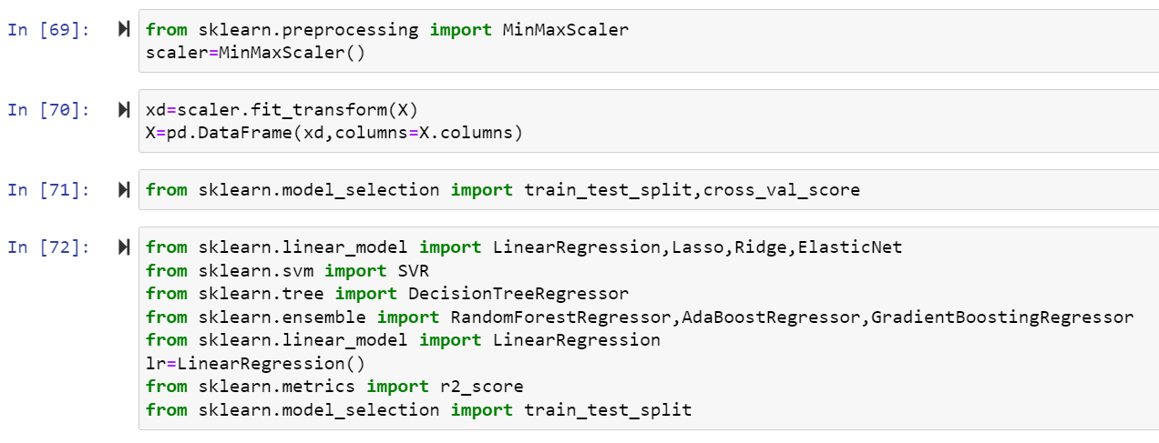

**Lasso Regression:**

The word “LASSO” stands for **L**east **A**bsolute **S**hrinkage and **S**election **O**perator. It is a statistical formula for the regularisation of data models and feature selection.LASSO or L1 regularization is a technique that can be used to improve many models, including generalized linear models (GLMs) and Neural networks. LASSO stands for “**least absolute shrinkage and selection operator**.” However, you might wonder if the phrase or the acronym came first.

**What is Lasso Regression**?

Lasso regression is a regularization technique. It is used over regression methods for a more accurate prediction. This model uses shrinkage. Shrinkage is where data values are shrunk towards a central point as the mean. The lasso procedure encourages simple, sparse models (i.e. models with fewer parameters). This particular type of regression is well-suited for models showing high levels of multicollinearity or when you want to automate certain parts of model selection, like variable selection/parameter elimination.

Lasso Regression uses L1 regularization technique (will be discussed later in this article). It is used when we have more number of features because it automatically performs feature selection.

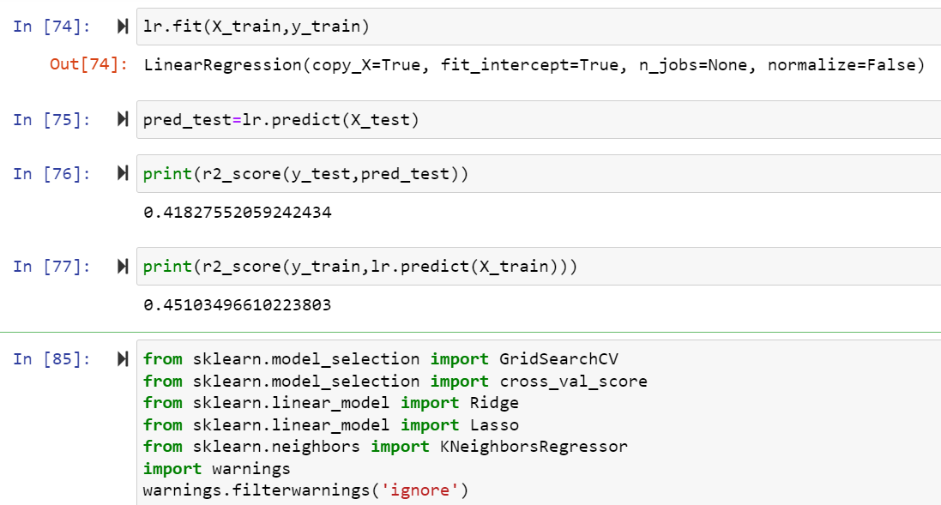

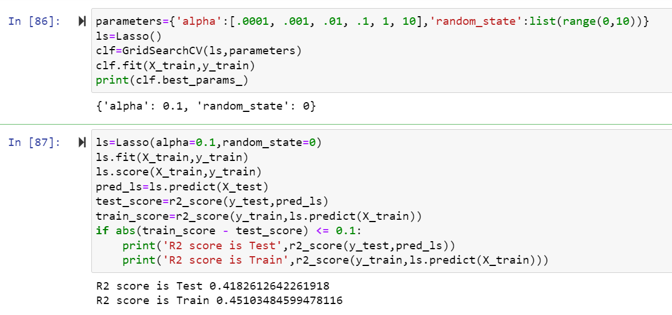 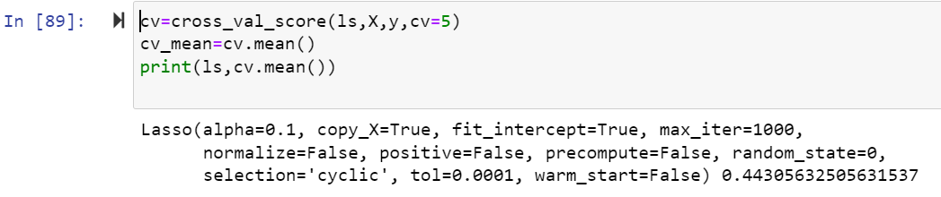

Here r2 score is 0.41 for train dataset and 0.45 for test dataset and cross validation score is 0.44 in Lasso algorithm.

**Ridge Regression:**

Ridge [regression](https://www.mygreatlearning.com/blog/what-is-regression/) is a model tuning method that is used to analyse any data that suffers from multicollinearity. This method performs L2 regularization. When the issue of multicollinearity occurs, least-squares are unbiased, and variances are large, this results in predicted values to be far away from the actual values.

**Ridge Regression Models**

For any type of regression machine learning models, the usual regression equation forms the base which is written as:

**Y = XB + e**

Where Y is the dependent variable, X represents the independent variables, B is the regression coefficients to be estimated, and e represents the errors are residuals. Once we add the lambda function to this equation, the variance that is not evaluated by the general model is considered. After the data is ready and identified to be part of L2 regularization, there are steps that one can undertake.

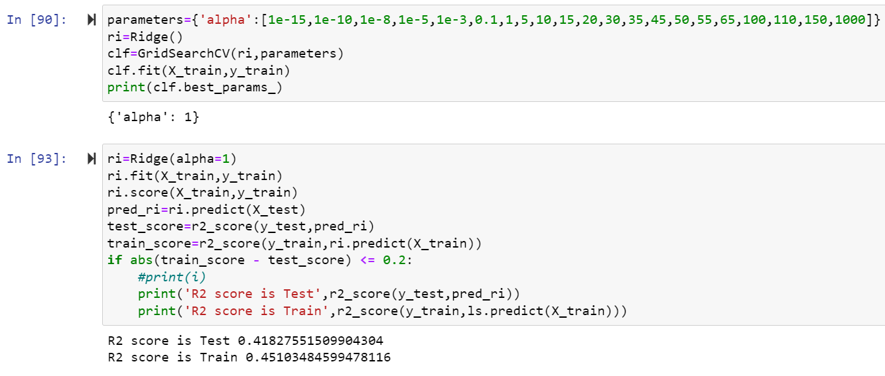

**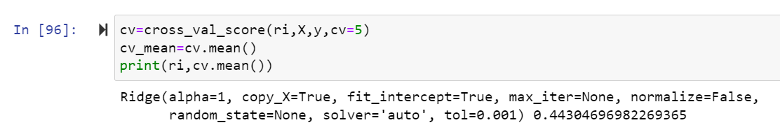**

Here r2 score is 0.41 for train dataset and 0.45 for test dataset and cross validation score is 0.44 in Ridge algorithm.

**RandomForest Regression:**

Random forest is a supervised learning algorithm. The "forest" it builds, is an ensemble of decision trees, usually trained with the “bagging” method. The general idea of the bagging method is that a combination of learning models increases the overall result.

Random forest is an ensemble of decision tree algorithms.It is an extension of [bootstrap aggregation (bagging)](https://machinelearningmastery.com/bagging-ensemble-with-python/) of decision trees and can be used for classification and regression problems.

In bagging, a number of decision trees are created where each tree is created from a different bootstrap sample of the training dataset. A [bootstrap sample](https://machinelearningmastery.com/a-gentle-introduction-to-the-bootstrap-method/) is a sample of the training dataset where a sample may appear more than once in the sample, referred to as **sampling with replacement**.

Bagging is an effective ensemble algorithm as each decision tree is fit on a slightly different training dataset, and in turn, has a slightly different performance. Unlike normal decision tree models, such as [classification and regression trees](https://machinelearningmastery.com/classification-and-regression-trees-for-machine-learning/) (CART), trees used in the ensemble are unpruned, making them slightly overfit to the training dataset. This is desirable as it helps to make each tree more different and have less correlated predictions or prediction errors.

Predictions from the trees are averaged across all decision trees resulting in better performance than any single tree in the model.

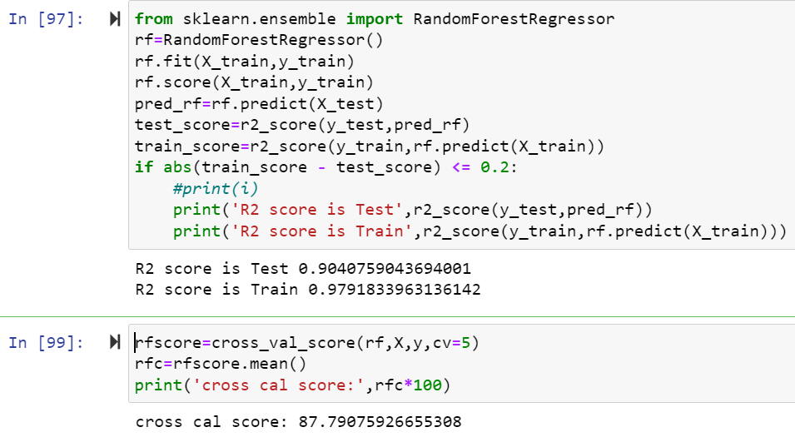

Here r2 score is 0.90 for train dataset and 0.97 for test dataset and cross validation score is 0.87 in RandomForestRegressor algorithm.

**SVR Regression:**

Support Vector Regression (SVR) uses the same principle as SVM, but for regression problems. Let’s spend a few minutes understanding the idea behind SVR.

Recall the idea of SVR. Here, you give a set of input vectors and defined an output. The SVR then fits a model and tries to learn from those input vectors and finally predicts the response for a given new input vector. While working with time series data like stock prices, you need to determine which will be the "feature vector".

This is because time series data is time-dependent i.e. there will be a lot of past values and you can not take everything as feature vectors. For example, you have a stock price data set that contains the prices of a single stock from the previous six months. Now, based on this data you want to forecast the future price of the stock.

Here, you have to transform the past data to build some feature vectors. There are many ways you can do this i.e. averaging the past one month's prices or the current price of the stock divided by the moving average. This will minimize the input vectors and make it easier for the SVR to fit them. SVR features are unordered x-y pairs, so you can not get a model that considers time order. If you want to maintain the time order, you can build separate SVRs i.e. one for the past 10 days, one for the past 1 month, etc. and then take the average of all the predictions and forecast the values.

#### Advantages and Disadvantages of Support Vector Regression

There are some key benefits to choose a support vector machine for regression tasks. There are some drawbacks as well. Let's talk about them-

**The key advantages are-**

* SVM works really well with high-dimensional data. If your data is in higher dimensions, it is wise to use SVR.
* For data with a clear margin of separations, SVM works relatively well.
* When data has more features than the number of observations, SVM is one of the best algorithms to use.
* As a discriminative model, it need not to memorize anything about data. Therefore, it is memory efficient.

**Some drawbacks are-**

* It is a bad option when the data has no clear margin of separation i.e. the target class contains overlapping data points.
* It does not work well with large data sets.
* For being a discriminative model, it separates the data points below and above a hyperplane. So, you will not get any probabilistic explanation of the output.
* It is hard to understand and interpret SVM as its underlying structure is quite complex.

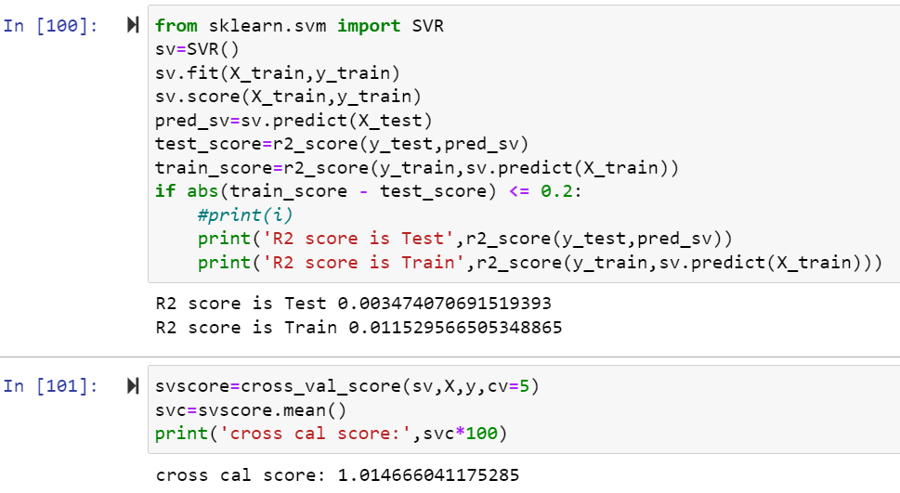

Here r2 score is 0.003 for train dataset and 0.011 test dataset and cross validation score is 1.01 SVR algorithm.

**DecisionTreeRegressor:**

Decision tree regression observes features of an object and trains a model in the structure of a tree to predict data in the future to produce meaningful continuous output. Continuous output means that the output/result is not discrete, i.e., it is not represented just by a discrete, known set of numbers or values.

**Decision Tree** is a decision-making tool that uses a flowchart-like tree structure or is a model of decisions and all of their possible results, including outcomes, input costs, and utility. Decision-tree algorithm falls under the category of supervised learning algorithms. It works for both continuous as well as categorical output variables.

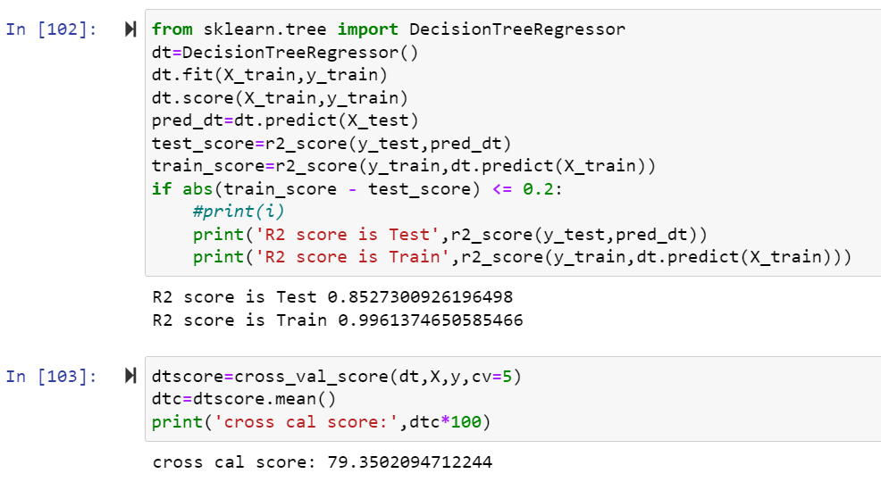

Here r2 score is 0.85 for train dataset and 0.99 for test dataset and cross validation score is 79 in DecisionTreeRegressor algorithm

**AdaBoostRegressor:**

Adaboost stands for Adaptive Boosting and it is widely used ensemble learning algorithm in machine learning. Weak learners are boosted by improving their weights and make them vote in creating a combined final model. In this post, we'll learn how to use [AdaBoostRegressor](https://scikit-learn.org/stable/modules/generated/sklearn.ensemble.AdaBoostRegressor.html" \t "_blank) class for the regression problem. AdaboostRegressor starts fitting the regressor with the dataset and adjusts the weights according to error rate. The tutorial covers:

* Preparing data
* Defining the model
* Predicting and checking the accuracy

**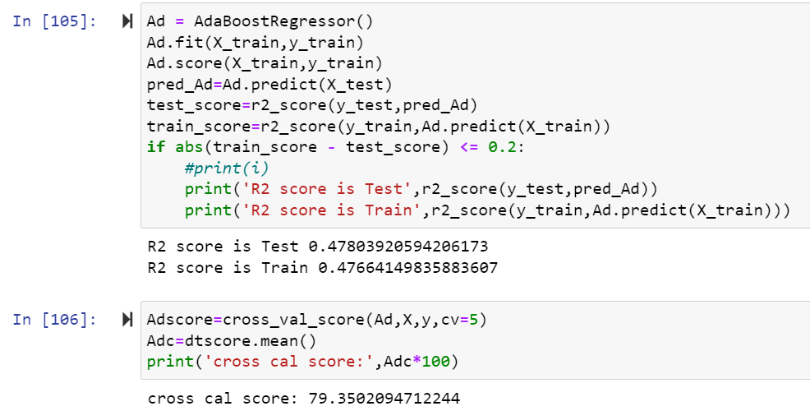**

Here r2 score is 0.47 for train dataset and 0.47 for test dataset and cross validation score is 79 in AdaBoostRegressor algorithm.

**KNN Regressor:**

As we saw above, KNN algorithm can be used for both classification and regression problems. The KNN algorithm uses '**feature similarity**' to predict the values of any new data points. This means that the new point is assigned a value based on how closely it resembles the points in the training set.

The kNN algorithm is one of the most famous [machine learning](https://realpython.com/learning-paths/machine-learning-python/) algorithms and an absolute must-have in your machine learning toolbox. Python is the go-to programming language for machine learning, so what better way to discover kNN than with Python’s famous packages [NumPy](https://realpython.com/numpy-tutorial/) and [scikit-learn](https://scikit-learn.org/stable/)!

Below, you’ll explore the kNN algorithm both in theory and in practice. While many tutorials skip the theoretical part and focus only on the use of libraries, you don’t want to be dependent on automated packages for your machine learning. It’s important to learn about the mechanics of machine learning algorithms to understand their potential and limitations.

At the same time, it’s essential to understand how to use an algorithm in practice. With that in mind, in the second part of this tutorial, you’ll focus on the use of kNN in the Python library scikit-learn, with advanced tips for pushing performance to the max.

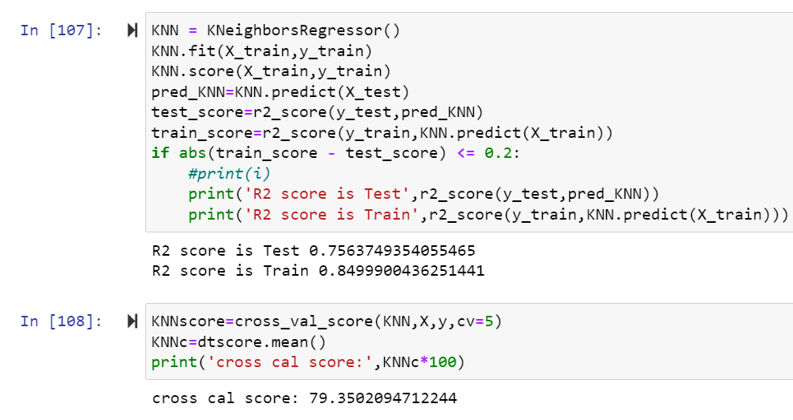

Here r2 score is 0.75 for train dataset and 0.84 for test dataset and cross validation score is 79 in KNN Regressor algorithm.

**GradientBoostingRegressor:**

Gradient Boosting for regression. GB builds an additive model in a forward stage-wise fashion; it **allows for the optimization of arbitrary differentiable loss functions**. In each stage a regression tree is fit on the negative gradient of the given loss function Gradient Boosting algorithm is used to generate an ensemble model by combining the weak learners or weak predictive models. Gradient boosting algorithm can be used to train models for both regression and classification problem. Gradient Boosting Regression algorithm is used to fit the model which predicts the continuous value.

Gradient boosting builds an additive mode by using multiple decision trees of fixed size as weak learners or weak predictive models. The parameter, n\_estimators, decides the number of decision trees which will be used in the boosting stages. **Gradient boosting differs from AdaBoost**in the manner that decision stumps (one node & two leaves) are used in AdaBoost whereas decision trees of fixed size are used in Gradient Boosting.

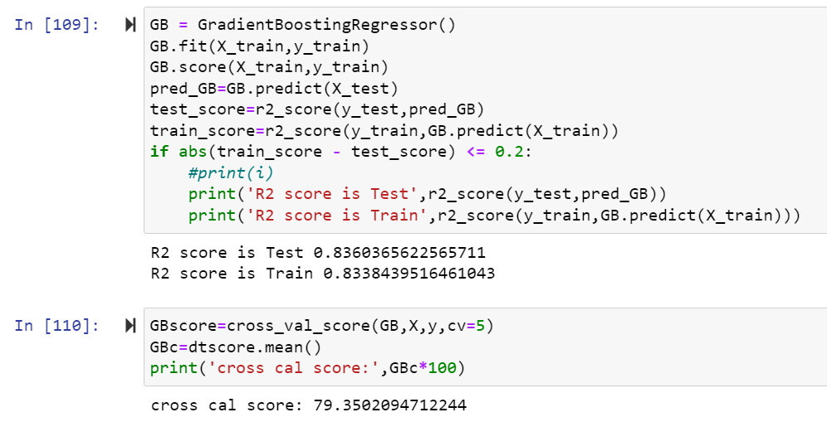

Here r2 score is 0.83 for train dataset and 0.83 for test dataset and cross validation score is 79 in GradientBoostRegressor algorithm.

**GridSearchCV :**

GridSearchCV is **a library function that** is a member of sklearn's model\_selection package. It helps to loop through predefined hyperparameters and fit your estimator (model) on your training set. So, in the end, you can select the best parameters from the listed hyperparameters.

**Parameterlist:**

There is a list of different machine learning models. They all are different in some way or the other, but what makes them different is nothing but input parameters for the model. These input parameters are named as **Hyperparameters.**These hyperparameters will define the architecture of the model, and the best part about these is that you get a choice to select these for your model. Of course, you must select from a specific list of hyperparameters for a given model as it varies from model to model.

There is a list of different machine learning models. They all are different in some way or the other, but what makes them different is nothing but input parameters for the model. These input parameters are named as **Hyperparameters.**These hyperparameters will define the architecture of the model, and the best part about these is that you get a choice to select these for your model. Of course, you must select from a specific list of hyperparameters for a given model as it varies from model to model.

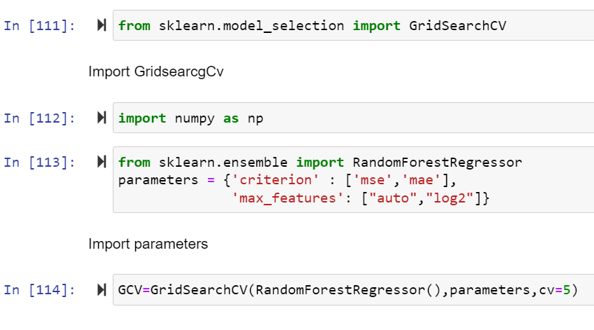

Here above are the parameter list of RandomForestRegressor model.

The above code block we have the following parameters  
max\_features: In this maximum features there are two values auto and auto,sqrt.

criterion is mse ,mae .

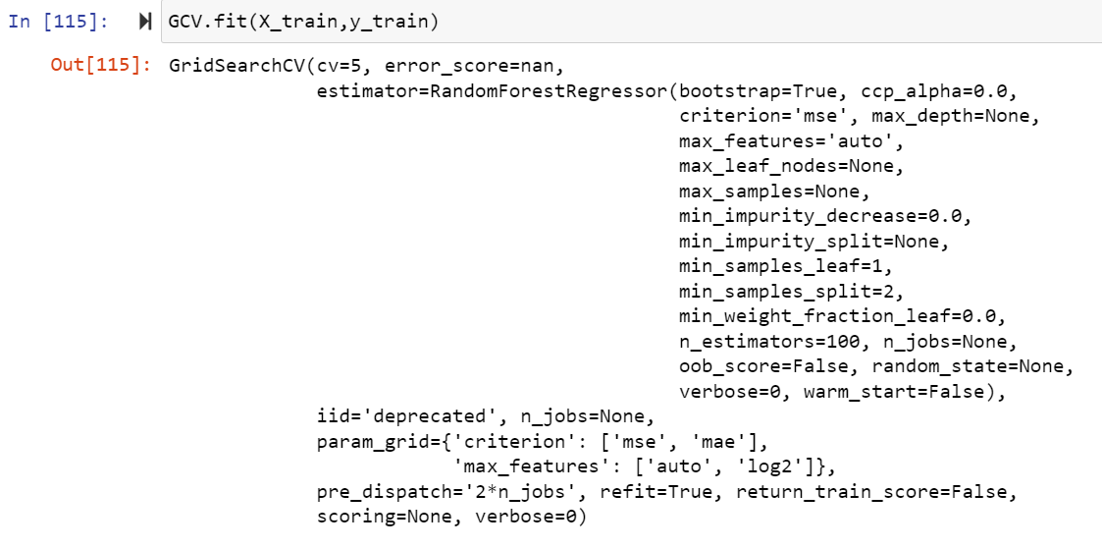 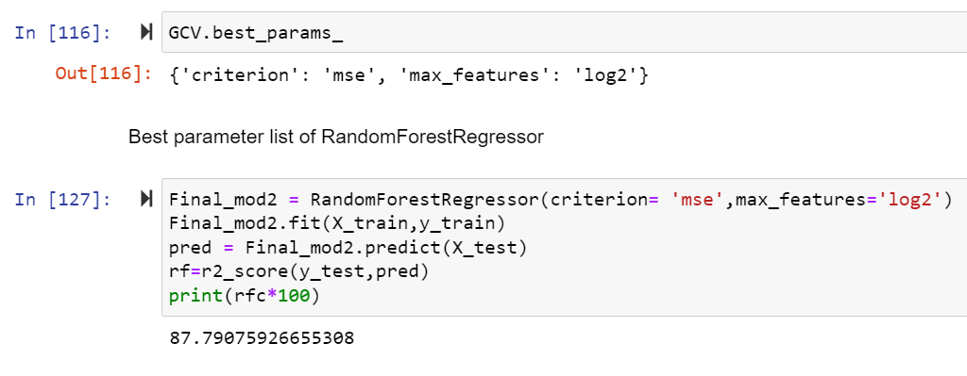

Here after use different parameter list the best parameter list is select. Above are the best parameter list RandomForestRegressor. Put this parameters into the model so output is finally best score os RandomForestRegressor is 87 so it is the best score.

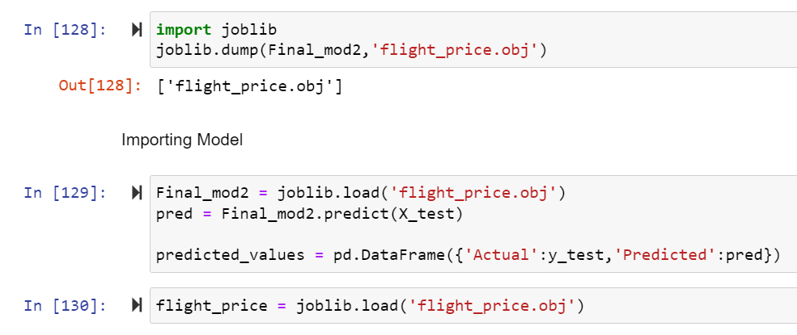

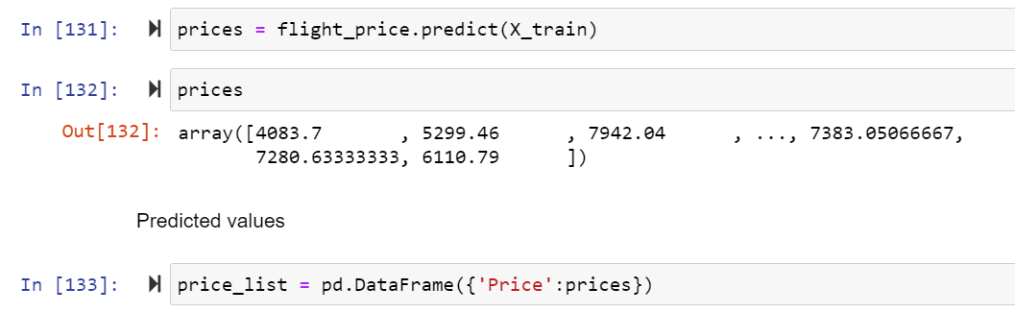

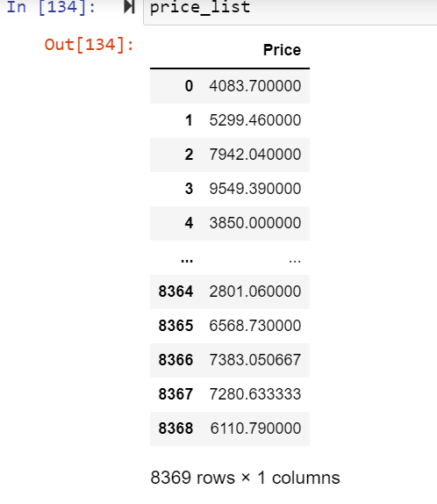

Finally Load the model and predict the values.

**Visualizations**

Mention all the plots made along with their pictures and what were the inferences and observations obtained from those. Describe them in detail.

**Interpretation of the Results**

From the data collected and through exploratory data analysis, we can determine the following:

● The trend of flight prices vary over various months.

● The airfare varies depending on the time of departure, making timeslot used in analysis is an important parameter.

● The airfare increases In our time period, the fare remained high for all the values of days to departure.

● Airfare varies according to the day of the week of travel. It is higher for weekends and Monday and slightly lower for the other days.

● There are a few times when an offer is run by an airline because of which the prices drop suddenly. These are difficult to incorporate in our mathematical models, and hence lead to error.

● Along the business routes, we find that the price of flights increases or remains constant as the days to departure decreases. This is because of the high frequency of the flights, high demand and also could be due to heavy competition.

**CONCLUSION**

A proper implementation of this project can result in saving money of inexperienced people by providing them the information related to trends that flight prices follow and also give them a predicted value of the price which they use to decide whether to book ticket now or later. In conclusion this type of service can be implemented with good accuracy of prediction. As the predicted value is not fully accurate there is huge scope for improvement of these kind of service.

In the proposed system the overall survey for the dynamic price changes in the flight tickets is presented. this gives the information about the highs and lows in the airfares accordingly. Now a days, weekend and time of the day that is morning, evening and night. also the machine learning models in the computational intelligence field that are evaluated before on different datasets are studied. their accuracy and performances are evaluated and compared in order to get better result. For the prediction of the ticket prices perfectly differnt prediction models are tested for the better prediction accuracy. As the pricing models of the company are developed in order to maximize the revenue management. So to get result with maximum accuracy regression analysis is used. From the studies , the feature that influences the prices of the ticket are to be considered. In future the details about number of availble seats can improve the performance of the model.

**Learning Outcomes of the Study in respect of Data Science**

List down your learnings obtained about the power of visualization, data cleaning and various algorithms used. You can describe which algorithm works best in which situation and what challenges you faced while working on this project and how did you overcome that.

In this project drop some columns because not much important.

Remove the null values using mean and median In this many columns null values are present so require time to remove null values of all the columns.

Use label encoder to convert categorical values into numeric.

In this using IQR technique more data loss.

Remove the skewness is difficult because dataset size is big and so much skewness is present so time is require to remove the skew ness.

Use different Regression modelling technique and using r2 score and cross validation score select random forest is the best model.

**Future Work**

More routes can be added and the same analysis can be expanded to major airports and travel routes .

The analysis can be done by increasing the data points and increasing the historical data used. That will train the model better giving better accuracies and more savings.

More rules can be added in the Rule based learning based on our understanding of the industry, also incorporating the offer periods given by the airlines.

Developing a more user friendly interface for various routes giving more flexibility to the users.